Subject: Machine Learning Lab

Subject Code: BCOP305

Teaching Scheme Examination Scheme

Practical: 4 Hrs/Week Continuous Assessment: 25 Marks
External Practical : 25 Marks

G.H.RAISONI COLLEGE OF ENGINEERING, WAGHOLI, PUNE
ACADEMIC YEAR: 2018-19

DEPARTMENT OF COMPUTER ENGINEERING
CLASS: T.Y. SEMESTER: VI
SUBJECT: MACHINE LEARNING LAB

LAB  EXPT. NO. | PROBLEM STATEMENT | Page No.
1 | Python Overview: Variables, String,List,Dictionary,Tuples,Comparison operators
2 | Python Overview: Control flow, loops, Functions
3 | Understanding data formats of Pandas: Series, Dataframe, Panel; Creating, Appending, Deleting. Importing different types of Datasets.
4 | Understanding data formats of Numpy: ndarrays (1D, 2D and 3D arrays), Array creation routines
5 | Matplotlib plotting for Data visualization: Tweaking Colors, Symbols, Formulations. Plotting Categorical data, 3D Axes, Parametric Curves, Trigonometry functions, Histogram, Bar, Pie chart. Graph plotting using Pandas
6 | Dataset selection: Dataset for Classification / Regression / Associative Rule Mining. and Analysis: Independent Variables, Dependent Variables, Handling Missing Values, Categorical data, and Feature Scaling
7 | Regression: Performing Simple Linear Regression over a salary dataset and predict salaries according to their experience years
8 | Regression & Data Valuation: Performing Multi-linear Regression (using appropriate Model) to evaluate with data which is useful for model training
9 | Regression: Using Polynomial regression resolve bluff query for new employee salary
10 | Classification: Using KNN (with WCSS) Predict if a customer with certain age and Salary will purchase a product or not
11 | Classification: Using Naïve Bayes Predict if a customer with certain age and Salary will purchase a product or not
12 | Classification: Using Decision Tree Predict if a customer with certain age and Salary will purchase a product or not
13 | Classification: Using SVM Predict if a customer with certain age and Salary will purchase a product or not
14 | Classification: Using RFC Predicting if a customer with certain age and Salary will purchase a product or not.
15 | Clustering: Using K-Means clustering, determine Customers of a Mall according to Categories so as to launch a scheme for business growth a product or not for imbalanced data and determining Fitting issues and Sampling methods and Optimizing techniques

G.H.RAISONI COLLEGE OF ENGINEERING, WAGHOLI, PUNE

DEPARTMENT OF COMPUTER ENGINEERING
ASSIGNMENT NUMBER 1

TITLE:
Python Overview: Variables, String, List, Dictionary, Tuples, Comparison operators

Theory:

Variables:

Variables are nothing but reserved memory locations to store values. This means that when you create a variable you reserve some space in memory.
Based on the data type of a variable, the interpreter allocates memory and decides what can be stored in the reserved memory. Therefore, by assigning different data types to variables, you can store integers, decimals or characters in these variables.

Assigning Values to Variables
Python variables do not need explicit declaration to reserve memory space. The declaration happens automatically when you assign a value to a variable. The equal sign (=) is used to assign values to variables.
The operand to the left of the = operator is the name of the variable and the operand to the right of the = operator is the value stored in the variable. For example −
#!/usr/bin/python
counter = 100 # An integer assignment
miles = 1000.0 # A floating point
name = "John" # A string
print counter
print miles
print name
Here, 100, 1000.0 and "John" are the values assigned to counter, miles, and name variables, respectively. This produces the following result −
100
1000.0
John

Multiple Assignment
Python allows you to assign a single value to several variables simultaneously. For example −
a = b = c = 1
Here, an integer object is created with the value 1, and all three variables are assigned to the same memory location. You can also assign multiple objects to multiple variables. For example −
a,b,c = 1,2,"john"
Here, two integer objects with values 1 and 2 are assigned to variables a and b respectively, and one string object with the value "john" is assigned to the variable c.

Standard Data Types
The data stored in memory can be of many types. For example, a person's age is stored as a numeric value and his or her address is stored as alphanumeric characters. Python has various standard data types that are used to define the operations possible on them and the storage method for each of them.
Python has five standard data types −
- Numbers
- String
- List
- Tuple
- Dictionary

Python Numbers
Number data types store numeric values. Number objects are created when you assign a value to them. For example −
var1 = 1
var2 = 10
You can also delete the reference to a number object by using the del statement. The syntax of the del statement is −
del var1[,var2[,var3[....,varN]]]]
You can delete a single object or multiple objects by using the del statement. For example −
del var
del var_a, var_b
Python supports four different numerical types −
- int (signed integers)
- long (long integers, they can also be represented in octal and hexadecimal)
- float (floating point real values)
- complex (complex numbers)

Examples
Here are some examples of numbers −
int | long | float | complex
10 | 51924361L | 0.0 | 3.14j
100 | -0x19323L | 15.20 | 45.j
-786 | 0122L | -21.9 | 9.322e-36j
080 | 0xDEFABCECBDAECBFBAEl | 32.3+e18 | .876j
-0490 | 535633629843L | -90. | -.6545+0J
-0x260 | -052318172735L | -32.54e100 | 3e+26J
0x69 | -4721885298529L | 70.2-E12 | 4.53e-7j
- Python allows you to use a lowercase l with long, but it is recommended that you use only an uppercase L to avoid confusion with the number 1. Python displays long integers with an uppercase L.
- A complex number consists of an ordered pair of real floating-point numbers denoted by x + yj, where x and y are the real numbers and j is the imaginary unit.

Python Strings
Strings in Python are identified as a contiguous set of characters represented in the quotation marks. Python allows for either pairs of single or double quotes. Subsets of strings can be taken using the slice operator ([ ] and [:] ) with indexes starting at 0 in the beginning of the string and working their way from -1 at the end.
The plus (+) sign is the string concatenation operator and the asterisk (*) is the repetition operator. For example −
#!/usr/bin/python

str = 'Hello World!'

print str # Prints complete string
print str[0] # Prints first character of the string
print str[2:5] # Prints characters starting from 3rd to 5th
print str[2:] # Prints string starting from 3rd character
print str * 2 # Prints string two times
print str + "TEST" # Prints concatenated string
This will produce the following result −
Hello World!
H
llo
llo World!
Hello World!Hello World!
Hello World!TEST

Python Lists
Lists are the most versatile of Python's compound data types. A list contains items separated by commas and enclosed within square brackets ([]). To some extent, lists are similar to arrays in C. One difference between them is that all the items belonging to a list can be of different data type.
The values stored in a list can be accessed using the slice operator ([ ] and [:]) with indexes starting at 0 in the beginning of the list and working their way to end -1. The plus (+) sign is the list concatenation operator, and the asterisk (*) is the repetition operator. For example −
#!/usr/bin/python

list = [ 'abcd', 786 , 2.23, 'john', 70.2 ]
tinylist = [123, 'john']

print list # Prints complete list
print list[0] # Prints first element of the list
print list[1:3] # Prints elements starting from 2nd till 3rd
print list[2:] # Prints elements starting from 3rd element
print tinylist * 2 # Prints list two times
print list + tinylist # Prints concatenated lists
This produce the following result −
['abcd', 786, 2.23, 'john', 70.2]
abcd
[786, 2.23]
[2.23, 'john', 70.2]
[123, 'john', 123, 'john']
['abcd', 786, 2.23, 'john', 70.2, 123, 'john']

Python Tuples
A tuple is another sequence data type that is similar to the list. A tuple consists of a number of values separated by commas. Unlike lists, however, tuples are enclosed within parentheses.
The main differences between lists and tuples are: Lists are enclosed in brackets ( [ ] ) and their elements and size can be changed, while tuples are enclosed in parentheses ( ( ) ) and cannot be updated. Tuples can be thought of as read-only lists. For example −
#!/usr/bin/python

tuple = ( 'abcd', 786 , 2.23, 'john', 70.2 )
tinytuple = (123, 'john')

print tuple # Prints complete list
print tuple[0] # Prints first element of the list
print tuple[1:3] # Prints elements starting from 2nd till 3rd
print tuple[2:] # Prints elements starting from 3rd element
print tinytuple * 2 # Prints list two times
print tuple + tinytuple # Prints concatenated lists
This produce the following result −
('abcd', 786, 2.23, 'john', 70.2)
abcd
(786, 2.23)
(2.23, 'john', 70.2)
(123, 'john', 123, 'john')
('abcd', 786, 2.23, 'john', 70.2, 123, 'john')
The following code is invalid with tuple, because we attempted to update a tuple, which is not allowed. Similar case is possible with lists −
#!/usr/bin/python

tuple = ( 'abcd', 786 , 2.23, 'john', 70.2 )
list = [ 'abcd', 786 , 2.23, 'john', 70.2 ]
tuple[2] = 1000 # Invalid syntax with tuple
list[2] = 1000 # Valid syntax with list

Python Dictionary
Python's dictionaries are kind of hash table type. They work like associative arrays or hashes found in Perl and consist of key-value pairs. A dictionary key can be almost any Python type, but are usually numbers or strings. Values, on the other hand, can be any arbitrary Python object.
Dictionaries are enclosed by curly braces ({ }) and values can be assigned and accessed using square braces ([]). For example −
#!/usr/bin/python

dict = {}
dict['one'] = "This is one"
dict[2] = "This is two"
tinydict = {'name': 'john','code':6734, 'dept': 'sales'}
print dict['one'] # Prints value for 'one' key
print dict[2] # Prints value for 2 key
print tinydict # Prints complete dictionary
print tinydict.keys() # Prints all the keys
print tinydict.values() # Prints all the values
This produce the following result −
This is one
This is two
{'dept': 'sales', 'code': 6734, 'name': 'john'}
['dept', 'code', 'name']
['sales', 6734, 'john']
Dictionaries have no concept of order among elements. It is incorrect to say that the elements are "out of order"; they are simply unordered.

Python - Basic Operators:
Operators are the constructs which can manipulate the value of operands.
Consider the expression 4 + 5 = 9. Here, 4 and 5 are called operands and + is called operator.

Types of Operator
Python language supports the following types of operators.
- Arithmetic Operators
- Comparison (Relational) Operators
- Assignment Operators
- Logical Operators
- Bitwise Operators
- Membership Operators
- Identity Operators
Let us have a look on all operators one by one.

Python Arithmetic Operators
Assume variable a holds 10 and variable b holds 20, then −

Operator | Description | Example
+ Addition | Adds values on either side of the operator. | a + b = 30
- Subtraction | Subtracts right hand operand from left hand operand. | a – b = -10
* Multiplication | Multiplies values on either side of the operator | a * b = 200
/ Division | Divides left hand operand by right hand operand | b / a = 2
% Modulus | Divides left hand operand by right hand operand and returns remainder | b % a = 0
** Exponent | Performs exponential (power) calculation on operators | a**b =10 to the power 20
// | Floor Division - The division of operands where the result is the quotient in which the digits after the decimal point are removed. But if one of the operands is negative, the result is floored, i.e., rounded away from zero (towards negative infinity) − | 9//2 = 4 and 9.0//2.0 = 4.0, -11//3 = -4, -11.0//3 = -4.0

Python Comparison Operators
These operators compare the values on either sides of them and decide the relation among them. They are also called Relational operators.
Assume variable a holds 10 and variable b holds 20, then −

Operator | Description | Example
== | If the values of two operands are equal, then the condition becomes true. | (a == b) is not true.
!= | If values of two operands are not equal, then condition becomes true. | (a != b) is true.
<> | If values of two operands are not equal, then condition becomes true. | (a <> b) is true. This is similar to != operator.
> | If the value of left operand is greater than the value of right operand, then condition becomes true. | (a > b) is not true.
< | If the value of left operand is less than the value of right operand, then condition becomes true. | (a < b) is true.
>= | If the value of left operand is greater than or equal to the value of right operand, then condition becomes true. | (a >= b) is not true.
<= | If the value of left operand is less than or equal to the value of right operand, then condition becomes true. | (a <= b) is true.

Python Assignment Operators
Assume variable a holds 10 and variable b holds 20, then −
Operator | Description | Example
= | Assigns values from right side operands to left side operand | c = a + b assigns value of a + b into c
+= Add AND | It adds right operand to the left operand and assign the result to left operand | c += a is equivalent to c = c + a
-= Subtract AND | It subtracts right operand from the left operand and assign the result to left operand | c -= a is equivalent to c = c - a
*= Multiply AND | It multiplies right operand with the left operand and assign the result to left operand | c *= a is equivalent to c = c * a
/= Divide AND | It divides left operand with the right operand and assign the result to left operand | c /= a is equivalent to c = c / ac /= a is equivalent to c = c / a
%= Modulus AND | It takes modulus using two operands and assign the result to left operand | c %= a is equivalent to c = c % a
**= Exponent AND | Performs exponential (power) calculation on operators and assign value to the left operand | c **= a is equivalent to c = c ** a
//= Floor Division | It performs floor division on operators and assign value to the left operand | c //= a is equivalent to c = c // a

Python Bitwise Operators
Bitwise operator works on bits and performs bit by bit operation. Assume if a = 60; and b = 13; Now in binary format they will be as follows −
a = 0011 1100
b = 0000 1101
-----------------
a&b = 0000 1100
a|b = 0011 1101
a^b = 0011 0001
~a = 1100 0011
There are following Bitwise operators supported by Python language
Operator | Description | Example
& Binary AND | Operator copies a bit to the result if it exists in both operands | (a & b) (means 0000 1100)
| Binary OR | It copies a bit if it exists in either operand. | (a | b) = 61 (means 0011 1101)
^ Binary XOR | It copies the bit if it is set in one operand but not both. | (a ^ b) = 49 (means 0011 0001)
~ Binary Ones Complement | It is unary and has the effect of 'flipping' bits. | (~a ) = -61 (means 1100 0011 in 2's complement form due to a signed binary number.
<< Binary Left Shift | The left operands value is moved left by the number of bits specified by the right operand. | a << 2 = 240 (means 1111 0000)
>> Binary Right Shift | The left operands value is moved right by the number of bits specified by the right operand. | a >> 2 = 15 (means 0000 1111)
Python Membership Operators
Python’s membership operators test for membership in a sequence, such as strings, lists, or tuples. There are two membership operators as explained below −

Operator | Description | Example
in | Evaluates to true if it finds a variable in the specified sequence and false otherwise. | x in y, here in results in a 1 if x is a member of sequence y.
not in | Evaluates to true if it does not finds a variable in the specified sequence and false otherwise. | x not in y, here not in results in a 1 if x is not a member of sequence y.

Python Identity Operators
Identity operators compare the memory locations of two objects. There are two Identity operators explained below −
Operator | Description | Example
is | Evaluates to true if the variables on either side of the operator point to the same object and false otherwise. | x is y, here is results in 1 if id(x) equals id(y).
is not | Evaluates to false if the variables on either side of the operator point to the same object and true otherwise. | x is not y, here is not results in 1 if id(x) is not equal to id(y).

Python Operators Precedence
The following table lists all operators from highest precedence to lowest.
Sr.No. | Operator & Description
1 | ** Exponentiation (raise to the power)
2 | ~ + - Complement, unary plus and minus (method names for the last two are +@ and -@)
3 | * / % // Multiply, divide, modulo and floor division
4 | + - Addition and subtraction
5 | >> << Right and left bitwise shift
6 | & Bitwise 'AND'
7 | ^ | Bitwise exclusive `OR' and regular `OR'
8 | <= < > >= Comparison operators
9 | <> == != Equality operators
10 | = %= /= //= -= += *= **= Assignment operators
11 | is is not Identity operators
12 | in not in Membership operators
13 | not or and Logical operators

Exercise:
  - Write a Python program to display the first and last colors from the following list.
color_list = ["Red","Green","White" ,"Black"]
  - Write a Python program to display the examination schedule. (extract the date from exam_st_date).
exam_st_date = (11, 12, 2014)
Sample Output: The examination will start from : 11 / 12 / 2014
  - Write a Python program to print the following floating numbers upto 2 decimal places: 3.1415926, 12.9999

G.H.RAISONI COLLEGE OF ENGINEERING, WAGHOLI, PUNE

DEPARTMENT OF COMPUTER ENGINEERING
ASSIGNMENT NUMBER 2

TITLE:

Python Overview: Control flow, loops, Functions

Theory:

Control Flow Statements
A program’s control flow is the order in which the program’s code executes. The control flow of a Python program is regulated by conditional statements, loops, and function calls. This section covers the if statement and for andwhile loops.

The if Statement
Often, you need to execute some statements only if some condition holds, or choose statements to execute depending on several mutually exclusive conditions. The Python compound statement if, which uses if, elif, andelse clauses, lets you conditionally execute blocks of statements. Here’s the syntax for the if statement:
if expression:
statement(s)
elif expression:
statement(s)
elif expression:
statement(s)
...
else:
statement(s)
The elif and else clauses are optional. Note that unlike some languages, Python does not have a switch statement, so you must use if, elif, and elsefor all conditional processing.
Here’s a typical if statement:
if x < 0: print "x is negative"
elif x % 2: print "x is positive and odd"
else: print "x is even and non-negative"
When there are multiple statements in a clause (i.e., the clause controls a block of statements), the statements are placed on separate logical lines after the line containing the clause’s keyword (known as the header line of the clause) and indented rightward from the header line. The block terminates when the indentation returns to that of the clause header (or further left from there). When there is just a single simple statement, as here, it can follow the : on the same logical line as the header, but it can also be placed on a separate logical line, immediately after the header line and indented rightward from it. Many Python practitioners consider the separate-line style more readable:
if x < 0:
print "x is negative"
elif x % 2:
print "x is positive and odd"
else:
print "x is even and non-negative"
You can use any Python expression as the condition in an if or elif clause. When you use an expression this way, you are using it in a Boolean context. In a Boolean context, any value is taken as either true or false. As we discussed earlier, any non-zero number or non-empty string, tuple, list, or dictionary evaluates as true. Zero (of any numeric type), None, and empty strings, tuples, lists, and dictionaries evaluate as false. When you want to test a value x in a Boolean context, use the following coding style:
if x:
This is the clearest and most Pythonic form. Don’t use:
if x is True:
if x = = True:
if bool(x):
There is a crucial difference between saying that an expression “returns True" (meaning the expression returns the value 1 intended as a Boolean result) and saying that an expression “evaluates as true” (meaning the expression returns any result that is true in a Boolean context). When testing an expression, you care about the latter condition, not the former.
If the expression for the if clause evaluates as true, the statements following the if clause execute, and the entire if statement ends. Otherwise, the expressions for any elif clauses are evaluated in order. The statements following the first elif clause whose condition is true, if any, are executed, and the entire if statement ends. Otherwise, if an else clause exists, the statements following it are executed.

The while Statement
The while statement in Python supports repeated execution of a statement or block of statements that is controlled by a conditional expression. Here’s the syntax for the while statement:
while expression:
statement(s)
A while statement can also include an else clause and break and continuestatements, as we’ll discuss shortly.
Here’s a typical while statement:
count = 0
while x > 0:
x = x // 2 # truncating division
count += 1
print "The approximate log2 is", count
First, expression, which is known as the loop condition, is evaluated. If the condition is false, the while statement ends. If the loop condition is satisfied, the statement or statements that comprise the loop body are executed. When the loop body finishes executing, the loop condition is evaluated again, to see if another iteration should be performed. This process continues until the loop condition is false, at which point the while statement ends.
The loop body should contain code that eventually makes the loop condition false, or the loop will never end unless an exception is raised or the loop body executes a break statement. A loop that is in a function’s body also ends if a return statement executes in the loop body, as the whole function ends in this case.

The for Statement
The for statement in Python supports repeated execution of a statement or block of statements that is controlled by an iterable expression. Here’s the syntax for the for statement:
for target in iterable:
statement(s)
Note that the in keyword is part of the syntax of the for statement and is functionally unrelated to the in operator used for membership testing. A forstatement can also include an else clause and break and continuestatements, as we’ll discuss shortly.
Here’s a typical for statement:
for letter in "ciao":
print "give me a", letter, "..."
iterable may be any Python expression suitable as an argument to built-in function iter, which returns an iterator object (explained in detail in the next section). target is normally an identifier that names the control variable of the loop; the for statement successively rebinds this variable to each item of the iterator, in order. The statement or statements that comprise the loopbody execute once for each item in iterable (unless the loop ends because an exception is raised or a break or return statement is executed).
A target with multiple identifiers is also allowed, as with an unpacking assignment. In this case, the iterator’s items must then be sequences, each with the same length, equal to the number of identifiers in the target. For example, when d is a dictionary, this is a typical way to loop on the items in d:
for key, value in d.items( ):
if not key or not value: del d[key] # keep only true keys and values
The items method returns a list of key/value pairs, so we can use a for loop with two identifiers in the target to unpack each item into key and value.
If the iterator has a mutable underlying object, that object must not be altered while a for loop is in progress on it. For example, the previous example cannot use iteritems instead of items. iteritems returns an iterator whose underlying object is d, so therefore the loop body cannot mutate d (by deld[key]). items returns a list, though, so d is not the underlying object of the iterator and the loop body can mutate d.
The control variable may be rebound in the loop body, but is rebound again to the next item in the iterator at the next iteration of the loop. The loop body does not execute at all if the iterator yields no items. In this case, the control variable is not bound or rebound in any way by the for statement. If the iterator yields at least one item, however, when the loop statement terminates, the control variable remains bound to the last value to which the loop statement has bound it. The following code is thus correct, as long as someseqis not empty:
for x in someseq:
process(x)
print "Last item processed was", x

Iterators
An iterator is any object i such that you can call i .next( ) without any arguments. i .next( ) returns the next item of iterator i, or, when iterator ihas no more items, raises a StopIteration exception. When you write a class (see Chapter 5), you can allow instances of the class to be iterators by defining such a method next. Most iterators are built by implicit or explicit calls to built-in function iter, covered in Chapter 8. Calling a generator also returns an iterator, as we’ll discuss later in this chapter.
The for statement implicitly calls iter to get an iterator. The following statement:
for x in c:
statement(s)
is equivalent to:
_temporary_iterator = iter(c)
while True:
try: x = _temporary_iterator.next( )
except StopIteration: break
statement(s)
Thus, if iter( c ) returns an iterator i such that i .next( ) never raisesStopIteration (an infinite iterator), the loop for x in c: never terminates (unless the statements in the loop body contain suitable break or return statements or propagate exceptions). iter( c ), in turn, calls special method c .__iter__( ) to obtain and return an iterator on c. We’ll talk more about the special method __iter__ in Chapter 5.
Iterators were first introduced in Python 2.2. In earlier versions, for x in S: required S to be a sequence that was indexable with progressively larger indices 0, 1, ..., and raised an IndexError when indexed with a too-large index. Thanks to iterators, the for statement can now be used on a container that is not a sequence, such as a dictionary, as long as the container is iterable (i.e., it defines an __iter__ special method so that function iter can accept the container as the argument and return an iterator on the container). Built-in functions that used to require a sequence argument now also accept any iterable.

range and xrange
Looping over a sequence of integers is a common task, so Python provides built-in functions range and xrange to generate and return integer sequences. The simplest, most idiomatic way to loop n times in Python is:
for i in xrange(n):
statement(s)
range( x ) returns a list whose items are consecutive integers from 0(included) up to x (excluded). range( x,y ) returns a list whose items are consecutive integers from x (included) up to y (excluded). The result is the empty list if x is greater than or equal to y. range( x,y,step ) returns a list of integers from x (included) up to y (excluded), such that the difference between each two adjacent items in the list is step. If step is less than 0, range counts down from x to y. range returns the empty list when x is greater than or equal to y and step is greater than 0, or when x is less than or equal to y and step is less than 0. If step equals 0, range raises an exception.
While range returns a normal list object, usable for all purposes, xrangereturns a special-purpose object, specifically intended to be used in iterations like the for statement shown previously. xrange consumes less memory thanrange for this specific use. Leaving aside memory consumption, you can use range wherever you could use xrange.

List comprehensions
A common use of a for loop is to inspect each item in a sequence and build a new list by appending the results of an expression computed on some or all of the items inspected. The expression form, called a list comprehension, lets you code this common idiom concisely and directly. Since a list comprehension is an expression (rather than a block of statements), you can use it directly wherever you need an expression (e.g., as an actual argument in a function call, in a return statement, or as a subexpression for some other expression).
A list comprehension has the following syntax:
[ expression for target in iterable
lc-clauses ]
target and iterable are the same as in a regular for statement. You must enclose the expression in parentheses if it indicates a tuple.
lc-clauses is a series of zero or more clauses, each with one of the following forms:
for target in iterable
if expression
target and iterable in each for clause of a list comprehension have the same syntax as those in a regular for statement, and the expression in each if clause of a list comprehension has the same syntax as the expression in a regular ifstatement.
A list comprehension is equivalent to a for loop that builds the same list by repeated calls to the resulting list’s append method. For example (assigning the list comprehension result to a variable for clarity):
result1 = [x+1 for x in some_sequence]
is the same as the for loop:
result2 = [ ]
for x in some_sequence:
result2.append(x+1)
Here’s a list comprehension that uses an if clause:
result3 = [x+1 for x in some_sequence if x>23]
which is the same as a for loop that contains an if statement:
result4 = [ ]
for x in some_sequence:
if x>23:
result4.append(x+1)
And here’s a list comprehension that uses a for clause:
result5 = [x+y for x in alist for y in another]
which is the same as a for loop with another for loop nested inside:
result6 = [ ]
for x in alist:
for y in another:
result6.append(x+y)
As these examples show, the order of for and if in a list comprehension is the same as in the equivalent loop, but in the list comprehension the nesting stays implicit.

The break Statement
The break statement is allowed only inside a loop body. When break executes, the loop terminates. If a loop is nested inside other loops, break terminates only the innermost nested loop. In practical use, a break statement is usually inside some clause of an if statement in the loop body so that it executes conditionally.
One common use of break is in the implementation of a loop that decides if it should keep looping only in the middle of each loop iteration:
while True: # this loop can never terminate naturally
x = get_next( )
y = preprocess(x)
if not keep_looping(x, y): break
process(x, y)

The continue Statement
The continue statement is allowed only inside a loop body. When continueexecutes, the current iteration of the loop body terminates, and execution continues with the next iteration of the loop. In practical use, a continuestatement is usually inside some clause of an if statement in the loop body so that it executes conditionally.
The continue statement can be used in place of deeply nested if statements within a loop. For example:
for x in some_container:
if not seems_ok(x): continue
lowbound, highbound = bounds_to_test( )
if x<lowbound or x>=highbound: continue
if final_check(x):
do_processing(x)
This equivalent code does conditional processing without continue:
for x in some_container:
if seems_ok(x):
lowbound, highbound = bounds_to_test( )
if lowbound<=x<highbound:
if final_check(x):
do_processing(x)
Both versions function identically, so which one you use is a matter of personal preference.

The else Clause on Loop Statements
Both the while and for statements may optionally have a trailing else clause. The statement or statements after the else execute when the loop terminates naturally (at the end of the for iterator or when the while loop condition becomes false), but not when the loop terminates prematurely (via break, return, or an exception). When a loop contains one or more break statements, you often need to check whether the loop terminates naturally or prematurely. You can use an else clause on the loop for this purpose:
for x in some_container:
if is_ok(x): break # item x is satisfactory, terminate loop
else:
print "Warning: no satisfactory item was found in container"
x = None

Python Functions:

A function is a block of code which only runs when it is called.
You can pass data, known as parameters, into a function.
A function can return data as a result.

Creating a Function
In Python a function is defined using the def keyword:

Example
def my_function():
print("Hello from a function")

Calling a Function
To call a function, use the function name followed by parenthesis:

Example
def my_function():
print("Hello from a function")
my_function()

Parameters
Information can be passed to functions as parameter.
Parameters are specified after the function name, inside the parentheses. You can add as many parameters as you want, just separate them with a comma.
The following example has a function with one parameter (fname). When the function is called, we pass along a first name, which is used inside the function to print the full name:

Example
def my_function(fname):
print(fname + " Refsnes")
my_function("Emil")
my_function("Tobias")
my_function("Linus")

Default Parameter Value
The following example shows how to use a default parameter value.
If we call the function without parameter, it uses the default value:

Example
def my_function(country = "Norway"):
print("I am from " + country)
my_function("Sweden")
my_function("India")
my_function()
my_function("Brazil")

Return Values
To let a function return a value, use the return statement:

Example
def my_function(x):
return 5 * x
print(my_function(3))
print(my_function(5))
print(my_function(9))
Exercise:
- Write a Python program to find those numbers which are divisible by 7 and multiple of 5, between 1500 and 2700 (both included).
- Write a Python program to convert temperatures to and from celsius, fahrenheit.
- Write a Python program that accepts a string and calculate the number of digits and letters.
- Write a Python program to check whether an alphabet is a vowel or consonant.
- Write a Python program to convert month name to a number of days.
- Write a Python program to find the median of three values.
- Write a Python function to find the Max of three numbers.
- Write a Python program to reverse a string.

G.H.RAISONI COLLEGE OF ENGINEERING, WAGHOLI, PUNE

DEPARTMENT OF COMPUTER ENGINEERING
ASSIGNMENT NUMBER 3

TITLE:
Understanding data formats of Pandas: Series, Dataframe, Panel; Creating, Appending, Deleting. Importing different types of Datasets.

Theory:

Pandas contains high-level data structures and manipulation tools designed to make data analysis fast and easy in Python. pandas is built on top of NumPy and makes it easy to use in NumPy-centric applications.

Pandas deals with the following three data structures −
- Series
- DataFrame
- Panel
These data structures are built on top of Numpy array, which means they are fast.

Dimension & Description
The best way to think of these data structures is that the higher dimensional data structure is a container of its lower dimensional data structure. For example, DataFrame is a container of Series, Panel is a container of DataFrame.
Data Structure | Dimensions | Description
Series | 1 | 1D labeled homogeneous array, sizeimmutable.
Data Frames | 2 | General 2D labeled, size-mutable tabular structure with potentially heterogeneously typed columns.
Panel | 3 | General 3D labeled, size-mutable array.

Series is a one-dimensional labeled array capable of holding data of any type (integer, string, float, python objects, etc.). The axis labels are collectively called index.

pandas.Series
A pandas Series can be created using the following constructor −
pandas.Series( data, index, dtype, copy)
The parameters of the constructor are as follows −
S.No | Parameter & Description
1 | data  data takes various forms like ndarray, list, constants
2 | index  Index values must be unique and hashable, same length as data. Default np.arrange(n) if no index is passed.
3 | dtype  dtype is for data type. If None, data type will be inferred
4 | copy  Copy data. Default False
A series can be created using various inputs like −
- Array
- Dict
- Scalar value or constant

Create an Empty Series
A basic series, which can be created is an Empty Series.

Example
#import the pandas library and aliasing as pd
import pandas as pd
s = pd.Series()
print s
Its output is as follows −
Series([], dtype: float64)

Create a Series from ndarray
If data is an ndarray, then index passed must be of the same length. If no index is passed, then by default index will be range(n) where n is array length, i.e., [0,1,2,3…. range(len(array))-1].

Example 1
#import the pandas library and aliasing as pd
import pandas as pd
import numpy as np
data = np.array(['a','b','c','d'])
s = pd.Series(data)
print s
Its output is as follows −
0 a
1 b
2 c
3 d
dtype: object
We did not pass any index, so by default, it assigned the indexes ranging from 0 to len(data)-1, i.e., 0 to 3.

Example 2
#import the pandas library and aliasing as pd
import pandas as pd
import numpy as np
data = np.array(['a','b','c','d'])
s = pd.Series(data,index=[100,101,102,103])
print s
Its output is as follows −
100 a
101 b
102 c
103 d
dtype: object
We passed the index values here. Now we can see the customized indexed values in the output.

Create a Series from dict
A dict can be passed as input and if no index is specified, then the dictionary keys are taken in a sorted order to construct index. If index is passed, the values in data corresponding to the labels in the index will be pulled out.

Example 1
#import the pandas library and aliasing as pd
import pandas as pd
import numpy as np
data = {'a' : 0., 'b' : 1., 'c' : 2.}
s = pd.Series(data)
print s
Its output is as follows −
a 0.0
b 1.0
c 2.0
dtype: float64
Observe − Dictionary keys are used to construct index.

Example 2
#import the pandas library and aliasing as pd
import pandas as pd
import numpy as np
data = {'a' : 0., 'b' : 1., 'c' : 2.}
s = pd.Series(data,index=['b','c','d','a'])
print s
Its output is as follows −
b 1.0
c 2.0
d NaN
a 0.0
dtype: float64
Observe − Index order is persisted and the missing element is filled with NaN (Not a Number).

Create a Series from Scalar
If data is a scalar value, an index must be provided. The value will be repeated to match the length of index
#import the pandas library and aliasing as pd
import pandas as pd
import numpy as np
s = pd.Series(5, index=[0, 1, 2, 3])
print s
Its output is as follows −
0 5
1 5
2 5
3 5
dtype: int64

Accessing Data from Series with Position
Data in the series can be accessed similar to that in an ndarray.

Example 1
Retrieve the first element. As we already know, the counting starts from zero for the array, which means the first element is stored at zeroth position and so on.
import pandas as pd
s = pd.Series([1,2,3,4,5],index = ['a','b','c','d','e'])

#retrieve the first element
print s[0]
Its output is as follows −
1

Example 2
Retrieve the first three elements in the Series. If a : is inserted in front of it, all items from that index onwards will be extracted. If two parameters (with : between them) is used, items between the two indexes (not including the stop index)
import pandas as pd
s = pd.Series([1,2,3,4,5],index = ['a','b','c','d','e'])

#retrieve the first three element
print s[:3]
Its output is as follows −
a 1
b 2
c 3
dtype: int64

A Data frame is a two-dimensional data structure, i.e., data is aligned in a tabular fashion in rows and columns.

Features of DataFrame
- Potentially columns are of different types
- Size – Mutable
- Labeled axes (rows and columns)
- Can Perform Arithmetic operations on rows and columns

Structure
Let us assume that we are creating a data frame with student’s data.
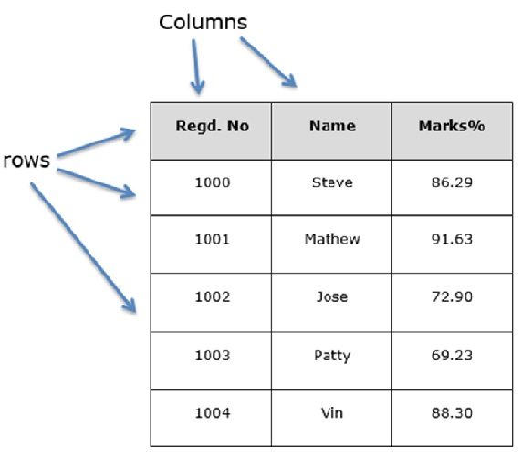
You can think of it as an SQL table or a spreadsheet data representation.

pandas.DataFrame
A pandas DataFrame can be created using the following constructor −
pandas.DataFrame( data, index, columns, dtype, copy)
The parameters of the constructor are as follows −
S.No | Parameter & Description
1 | data  data takes various forms like ndarray, series, map, lists, dict, constants and also another DataFrame.
2 | index  For the row labels, the Index to be used for the resulting frame is Optional Default np.arrange(n) if no index is passed.
3 | columns  For column labels, the optional default syntax is - np.arrange(n). This is only true if no index is passed.
4 | dtype  Data type of each column.
4 | copy  This command (or whatever it is) is used for copying of data, if the default is False.

Create DataFrame
A pandas DataFrame can be created using various inputs like −
- Lists
- dict
- Series
- Numpy ndarrays
- Another DataFrame
In the subsequent sections of this chapter, we will see how to create a DataFrame using these inputs.

Create an Empty DataFrame
A basic DataFrame, which can be created is an Empty Dataframe.

Example
#import the pandas library and aliasing as pd
import pandas as pd
df = pd.DataFrame()
print df

Its output is as follows −
Empty DataFrame
Columns: []
Index: []

Create a DataFrame from Lists
The DataFrame can be created using a single list or a list of lists.

Example 1
import pandas as pd
data = [1,2,3,4,5]
df = pd.DataFrame(data)
print df
Its output is as follows −
0
0 1
1 2
2 3
3 4
4 5

Example 2
import pandas as pd
data = [['Alex',10],['Bob',12],['Clarke',13]]
df = pd.DataFrame(data,columns=['Name','Age'])
print df
Its output is as follows −
Name Age
0 Alex 10
1 Bob 12
2 Clarke 13

Example 3
import pandas as pd
data = [['Alex',10],['Bob',12],['Clarke',13]]
df = pd.DataFrame(data,columns=['Name','Age'],dtype=float)
print df
Its output is as follows −
Name Age
0 Alex 10.0
1 Bob 12.0
2 Clarke 13.0
Note − Observe, the dtype parameter changes the type of Age column to floating point.

Create a DataFrame from Dict of ndarrays / Lists
All the ndarrays must be of same length. If index is passed, then the length of the index should equal to the length of the arrays.
If no index is passed, then by default, index will be range(n), where n is the array length.

Example 1
import pandas as pd
data = {'Name':['Tom', 'Jack', 'Steve', 'Ricky'],'Age':[28,34,29,42]}
df = pd.DataFrame(data)
print df
Its output is as follows −
Age Name
0 28 Tom
1 34 Jack
2 29 Steve
3 42 Ricky
Note − Observe the values 0,1,2,3. They are the default index assigned to each using the function range(n).

Example 2
Let us now create an indexed DataFrame using arrays.
import pandas as pd
data = {'Name':['Tom', 'Jack', 'Steve', 'Ricky'],'Age':[28,34,29,42]}
df = pd.DataFrame(data, index=['rank1','rank2','rank3','rank4'])
print df
Its output is as follows −
Age Name
rank1 28 Tom
rank2 34 Jack
rank3 29 Steve
rank4 42 Ricky
Note − Observe, the index parameter assigns an index to each row.

Create a DataFrame from List of Dicts
List of Dictionaries can be passed as input data to create a DataFrame. The dictionary keys are by default taken as column names.

Example 1
The following example shows how to create a DataFrame by passing a list of dictionaries.
import pandas as pd
data = [{'a': 1, 'b': 2},{'a': 5, 'b': 10, 'c': 20}]
df = pd.DataFrame(data)
print df
Its output is as follows −
a b c
0 1 2 NaN
1 5 10 20.0
Note − Observe, NaN (Not a Number) is appended in missing areas.

Example 2
The following example shows how to create a DataFrame by passing a list of dictionaries and the row indices.
import pandas as pd
data = [{'a': 1, 'b': 2},{'a': 5, 'b': 10, 'c': 20}]
df = pd.DataFrame(data, index=['first', 'second'])
print df
Its output is as follows −
a b c
first 1 2 NaN
second 5 10 20.0

Example 3
The following example shows how to create a DataFrame with a list of dictionaries, row indices, and column indices.
import pandas as pd
data = [{'a': 1, 'b': 2},{'a': 5, 'b': 10, 'c': 20}]

#With two column indices, values same as dictionary keys
df1 = pd.DataFrame(data, index=['first', 'second'], columns=['a', 'b'])

#With two column indices with one index with other name
df2 = pd.DataFrame(data, index=['first', 'second'], columns=['a', 'b1'])
print df1
print df2
Its output is as follows −
#df1 output
a b
first 1 2
second 5 10

#df2 output
a b1
first 1 NaN
second 5 NaN
Note − Observe, df2 DataFrame is created with a column index other than the dictionary key; thus, appended the NaN’s in place. Whereas, df1 is created with column indices same as dictionary keys, so NaN’s appended.

Create a DataFrame from Dict of Series
Dictionary of Series can be passed to form a DataFrame. The resultant index is the union of all the series indexes passed.

Example
import pandas as pd

d = {'one' : pd.Series([1, 2, 3], index=['a', 'b', 'c']),
'two' : pd.Series([1, 2, 3, 4], index=['a', 'b', 'c', 'd'])}

df = pd.DataFrame(d)
print df
Its output is as follows −
one two
a 1.0 1
b 2.0 2
c 3.0 3
d NaN 4
Note − Observe, for the series one, there is no label ‘d’ passed, but in the result, for the d label, NaN is appended with NaN.
Let us now understand column selection, addition, and deletion through examples.

Column Selection
We will understand this by selecting a column from the DataFrame.

Example
import pandas as pd

d = {'one' : pd.Series([1, 2, 3], index=['a', 'b', 'c']),
'two' : pd.Series([1, 2, 3, 4], index=['a', 'b', 'c', 'd'])}

df = pd.DataFrame(d)
print df ['one']
Its output is as follows −
a 1.0
b 2.0
c 3.0
d NaN
Name: one, dtype: float64

Column Addition
We will understand this by adding a new column to an existing data frame.

Example
import pandas as pd

d = {'one' : pd.Series([1, 2, 3], index=['a', 'b', 'c']),
'two' : pd.Series([1, 2, 3, 4], index=['a', 'b', 'c', 'd'])}

df = pd.DataFrame(d)

# Adding a new column to an existing DataFrame object with column label by passing new series

print ("Adding a new column by passing as Series:")
df['three']=pd.Series([10,20,30],index=['a','b','c'])
print df

print ("Adding a new column using the existing columns in DataFrame:")
df['four']=df['one']+df['three']

print df
Its output is as follows −
Adding a new column by passing as Series:
one two three
a 1.0 1 10.0
b 2.0 2 20.0
c 3.0 3 30.0
d NaN 4 NaN

Adding a new column using the existing columns in DataFrame:
one two three four
a 1.0 1 10.0 11.0
b 2.0 2 20.0 22.0
c 3.0 3 30.0 33.0
d NaN 4 NaN NaN

Column Deletion
Columns can be deleted or popped; let us take an example to understand how.

Example
# Using the previous DataFrame, we will delete a column
# using del function
import pandas as pd

d = {'one' : pd.Series([1, 2, 3], index=['a', 'b', 'c']),
'two' : pd.Series([1, 2, 3, 4], index=['a', 'b', 'c', 'd']),
'three' : pd.Series([10,20,30], index=['a','b','c'])}

df = pd.DataFrame(d)
print ("Our dataframe is:")
print df

# using del function
print ("Deleting the first column using DEL function:")
del df['one']
print df

# using pop function
print ("Deleting another column using POP function:")
df.pop('two')
print df
Its output is as follows −
Our dataframe is:
one three two
a 1.0 10.0 1
b 2.0 20.0 2
c 3.0 30.0 3
d NaN NaN 4

Deleting the first column using DEL function:
three two
a 10.0 1
b 20.0 2
c 30.0 3
d NaN 4

Deleting another column using POP function:
three
a 10.0
b 20.0
c 30.0
d NaN

Row Selection, Addition, and Deletion
We will now understand row selection, addition and deletion through examples. Let us begin with the concept of selection.

Selection by Label
Rows can be selected by passing row label to a loc function.
import pandas as pd

d = {'one' : pd.Series([1, 2, 3], index=['a', 'b', 'c']),
'two' : pd.Series([1, 2, 3, 4], index=['a', 'b', 'c', 'd'])}

df = pd.DataFrame(d)
print df.loc['b']
Its output is as follows −
one 2.0
two 2.0
Name: b, dtype: float64
The result is a series with labels as column names of the DataFrame. And, the Name of the series is the label with which it is retrieved.

Selection by integer location
Rows can be selected by passing integer location to an iloc function.
import pandas as pd

d = {'one' : pd.Series([1, 2, 3], index=['a', 'b', 'c']),
'two' : pd.Series([1, 2, 3, 4], index=['a', 'b', 'c', 'd'])}

df = pd.DataFrame(d)
print df.iloc[2]
Its output is as follows −
one 3.0
two 3.0
Name: c, dtype: float64

Slice Rows
Multiple rows can be selected using ‘ : ’ operator.
import pandas as pd

d = {'one' : pd.Series([1, 2, 3], index=['a', 'b', 'c']),
'two' : pd.Series([1, 2, 3, 4], index=['a', 'b', 'c', 'd'])}

df = pd.DataFrame(d)
print df[2:4]
Its output is as follows −
one two
c 3.0 3
d NaN 4

Addition of Rows
Add new rows to a DataFrame using the append function. This function will append the rows at the end.
import pandas as pd

df = pd.DataFrame([[1, 2], [3, 4]], columns = ['a','b'])
df2 = pd.DataFrame([[5, 6], [7, 8]], columns = ['a','b'])

df = df.append(df2)
print df
Its output is as follows −
a b
0 1 2
1 3 4
0 5 6
1 7 8

Deletion of Rows
Use index label to delete or drop rows from a DataFrame. If label is duplicated, then multiple rows will be dropped.
If you observe, in the above example, the labels are duplicate. Let us drop a label and will see how many rows will get dropped.
import pandas as pd

df = pd.DataFrame([[1, 2], [3, 4]], columns = ['a','b'])
df2 = pd.DataFrame([[5, 6], [7, 8]], columns = ['a','b'])

df = df.append(df2)

# Drop rows with label 0
df = df.drop(0)

print df
Its output is as follows −
a b
1 3 4
1 7 8
In the above example, two rows were dropped because those two contain the same label 0.

A panel is a 3D container of data. The term Panel data is derived from econometrics and is partially responsible for the name pandas − pan(el)-da(ta)-s.
The names for the 3 axes are intended to give some semantic meaning to describing operations involving panel data. They are −
- items − axis 0, each item corresponds to a DataFrame contained inside.
- major_axis − axis 1, it is the index (rows) of each of the DataFrames.
- minor_axis − axis 2, it is the columns of each of the DataFrames.

pandas.Panel()
A Panel can be created using the following constructor −
pandas.Panel(data, items, major_axis, minor_axis, dtype, copy)
The parameters of the constructor are as follows −
Parameter | Description
Data | Data takes various forms like ndarray, series, map, lists, dict, constants and also another DataFrame
Items | axis=0
major_axis | axis=1
minor_axis | axis=2
Dtype | Data type of each column
Copy | Copy data. Default, false

Create Panel
A Panel can be created using multiple ways like −
- From ndarrays
- From dict of DataFrames

From 3D ndarray
# creating an empty panel
import pandas as pd
import numpy as np

data = np.random.rand(2,4,5)
p = pd.Panel(data)
print p
Its output is as follows −
<class 'pandas.core.panel.Panel'>
Dimensions: 2 (items) x 4 (major_axis) x 5 (minor_axis)
Items axis: 0 to 1
Major_axis axis: 0 to 3
Minor_axis axis: 0 to 4
Note − Observe the dimensions of the empty panel and the above panel, all the objects are different.

From dict of DataFrame Objects
#creating an empty panel
import pandas as pd
import numpy as np

data = {'Item1' : pd.DataFrame(np.random.randn(4, 3)),
'Item2' : pd.DataFrame(np.random.randn(4, 2))}
p = pd.Panel(data)
print p
Its output is as follows −
<class 'pandas.core.panel.Panel'>
Dimensions: 2 (items) x 4 (major_axis) x 5 (minor_axis)
Items axis: 0 to 1
Major_axis axis: 0 to 3
Minor_axis axis: 0 to 4

Create an Empty Panel
An empty panel can be created using the Panel constructor as follows −
#creating an empty panel
import pandas as pd
p = pd.Panel()
print p
Its output is as follows −
<class 'pandas.core.panel.Panel'>
Dimensions: 0 (items) x 0 (major_axis) x 0 (minor_axis)
Items axis: None
Major_axis axis: None
Minor_axis axis: None

Selecting the Data from Panel
Select the data from the panel using −
- Items
- Major_axis
- Minor_axis

Using Items
# creating an empty panel
import pandas as pd
import numpy as np
data = {'Item1' : pd.DataFrame(np.random.randn(4, 3)),
'Item2' : pd.DataFrame(np.random.randn(4, 2))}
p = pd.Panel(data)
print p['Item1']
Its output is as follows −
0 1 2
0 0.488224 -0.128637 0.930817
1 0.417497 0.896681 0.576657
2 -2.775266 0.571668 0.290082
3 -0.400538 -0.144234 1.110535
We have two items, and we retrieved item1. The result is a DataFrame with 4 rows and 3 columns, which are the Major_axis and Minor_axis dimensions.

Using major_axis
Data can be accessed using the method panel.major_axis(index).
# creating an empty panel
import pandas as pd
import numpy as np
data = {'Item1' : pd.DataFrame(np.random.randn(4, 3)),
'Item2' : pd.DataFrame(np.random.randn(4, 2))}
p = pd.Panel(data)
print p.major_xs(1)
Its output is as follows −
Item1 Item2
0 0.417497 0.748412
1 0.896681 -0.557322
2 0.576657 NaN

Using minor_axis
Data can be accessed using the method panel.minor_axis(index).
# creating an empty panel
import pandas as pd
import numpy as np
data = {'Item1' : pd.DataFrame(np.random.randn(4, 3)),
'Item2' : pd.DataFrame(np.random.randn(4, 2))}
p = pd.Panel(data)
print p.minor_xs(1)
Its output is as follows −
Item1 Item2
0 -0.128637 -1.047032
1 0.896681 -0.557322
2 0.571668 0.431953
3 -0.144234 1.302466
Note − Observe the changes in the dimensions.

Conclusion:

G.H.RAISONI COLLEGE OF ENGINEERING, WAGHOLI, PUNE

DEPARTMENT OF COMPUTER ENGINEERING
ASSIGNMENT NUMBER 4

TITLE:
Understanding data formats of Numpy: ndarrays (1D, 2D and 3D arrays), Array creation routines

THEORY:
What are Numpy and numpy arrays
Python has built-in:
- containers: lists (costless insertion and append), dictionnaries (fast lookup)
- high-level number objects: integers, floating point
Numpy is:
- extension package to Python for multidimensional arrays
- closer to hardware (efficiency)
- designed for scientific computation (convenience)
- import numpy as np
- >>> a = np.array([0, 1, 2, 3])
- >>> a
- array([0, 1, 2, 3])

Creating arrays
1-D:
>>> a = np.array([0, 1, 2, 3])
>>> a
array([0, 1, 2, 3])
>>> a.ndim
1
>>> a.shape
(4,)
>>> len(a)
4
2-D, 3-D, ...:
>>> b = np.array([[0, 1, 2], [3, 4, 5]]) # 2 x 3 array
>>> b
array([[ 0, 1, 2],
[ 3, 4, 5]])
>>> b.ndim
2
>>> b.shape
(2, 3)
>>> len(b) # returns the size of the first dimension
2

>>> c = np.array([[[1], [2]], [[3], [4]]])
>>> c
array([[[1],
[2]],

[[3],
[4]]])
>>> c.shape
(2, 2, 1)

Array indexing
Numpy offers several ways to index into arrays.
Slicing: Similar to Python lists, numpy arrays can be sliced. Since arrays may be multidimensional, you must specify a slice for each dimension of the array:
import numpy as np

# Create the following rank 2 array with shape (3, 4)
# [[ 1 2 3 4]
# [ 5 6 7 8]
# [ 9 10 11 12]]
a = np.array([[1,2,3,4], [5,6,7,8], [9,10,11,12]])

# Use slicing to pull out the subarray consisting of the first 2 rows
# and columns 1 and 2; b is the following array of shape (2, 2):
# [[2 3]
# [6 7]]
b = a[:2, 1:3]

# A slice of an array is a view into the same data, so modifying it
# will modify the original array.
print(a[0, 1]) # Prints "2"
b[0, 0] = 77 # b[0, 0] is the same piece of data as a[0, 1]
print(a[0, 1]) # Prints "77"
You can also mix integer indexing with slice indexing. However, doing so will yield an array of lower rank than the original array. Note that this is quite different from the way that MATLAB handles array slicing:
import numpy as np

# Create the following rank 2 array with shape (3, 4)
# [[ 1 2 3 4]
# [ 5 6 7 8]
# [ 9 10 11 12]]
a = np.array([[1,2,3,4], [5,6,7,8], [9,10,11,12]])

# Two ways of accessing the data in the middle row of the array.
# Mixing integer indexing with slices yields an array of lower rank,
# while using only slices yields an array of the same rank as the
# original array:
row_r1 = a[1, :] # Rank 1 view of the second row of a
row_r2 = a[1:2, :] # Rank 2 view of the second row of a
print(row_r1, row_r1.shape) # Prints "[5 6 7 8] (4,)"
print(row_r2, row_r2.shape) # Prints "[[5 6 7 8]] (1, 4)"

# We can make the same distinction when accessing columns of an array:
col_r1 = a[:, 1]
col_r2 = a[:, 1:2]
print(col_r1, col_r1.shape) # Prints "[ 2 6 10] (3,)"
print(col_r2, col_r2.shape) # Prints "[[ 2]
# [ 6]
# [10]] (3, 1)"
Integer array indexing: When you index into numpy arrays using slicing, the resulting array view will always be a subarray of the original array. In contrast, integer array indexing allows you to construct arbitrary arrays using the data from another array. Here is an example:
import numpy as np

a = np.array([[1,2], [3, 4], [5, 6]])

# An example of integer array indexing.
# The returned array will have shape (3,) and
print(a[[0, 1, 2], [0, 1, 0]]) # Prints "[1 4 5]"

# The above example of integer array indexing is equivalent to this:
print(np.array([a[0, 0], a[1, 1], a[2, 0]])) # Prints "[1 4 5]"

# When using integer array indexing, you can reuse the same
# element from the source array:
print(a[[0, 0], [1, 1]]) # Prints "[2 2]"

# Equivalent to the previous integer array indexing example
print(np.array([a[0, 1], a[0, 1]])) # Prints "[2 2]"
One useful trick with integer array indexing is selecting or mutating one element from each row of a matrix:
import numpy as np

# Create a new array from which we will select elements
a = np.array([[1,2,3], [4,5,6], [7,8,9], [10, 11, 12]])

print(a) # prints "array([[ 1, 2, 3],
# [ 4, 5, 6],
# [ 7, 8, 9],
# [10, 11, 12]])"

# Create an array of indices
b = np.array([0, 2, 0, 1])

# Select one element from each row of a using the indices in b
print(a[np.arange(4), b]) # Prints "[ 1 6 7 11]"

# Mutate one element from each row of a using the indices in b
a[np.arange(4), b] += 10

print(a) # prints "array([[11, 2, 3],
# [ 4, 5, 16],
# [17, 8, 9],
# [10, 21, 12]])
Boolean array indexing: Boolean array indexing lets you pick out arbitrary elements of an array. Frequently this type of indexing is used to select the elements of an array that satisfy some condition. Here is an example:
import numpy as np

a = np.array([[1,2], [3, 4], [5, 6]])

bool_idx = (a > 2) # Find the elements of a that are bigger than 2;
# this returns a numpy array of Booleans of the same
# shape as a, where each slot of bool_idx tells
# whether that element of a is > 2.

print(bool_idx) # Prints "[[False False]
# [ True True]
# [ True True]]"

# We use boolean array indexing to construct a rank 1 array
# consisting of the elements of a corresponding to the True values
# of bool_idx
print(a[bool_idx]) # Prints "[3 4 5 6]"

# We can do all of the above in a single concise statement:
print(a[a > 2]) # Prints "[3 4 5 6]"
For brevity we have left out a lot of details about numpy array indexing; if you want to know more you should read the documentation.

Datatypes
Every numpy array is a grid of elements of the same type. Numpy provides a large set of numeric datatypes that you can use to construct arrays. Numpy tries to guess a datatype when you create an array, but functions that construct arrays usually also include an optional argument to explicitly specify the datatype. Here is an example:
import numpy as np

x = np.array([1, 2]) # Let numpy choose the datatype
print(x.dtype) # Prints "int64"

x = np.array([1.0, 2.0]) # Let numpy choose the datatype
print(x.dtype) # Prints "float64"

x = np.array([1, 2], dtype=np.int64) # Force a particular datatype
print(x.dtype) # Prints "int64"
You can read all about numpy datatypes in the documentation.

Array math
Basic mathematical functions operate elementwise on arrays, and are available both as operator overloads and as functions in the numpy module:
import numpy as np

x = np.array([[1,2],[3,4]], dtype=np.float64)
y = np.array([[5,6],[7,8]], dtype=np.float64)

# Elementwise sum; both produce the array
# [[ 6.0 8.0]
# [10.0 12.0]]
print(x + y)
print(np.add(x, y))

# Elementwise difference; both produce the array
# [[-4.0 -4.0]
# [-4.0 -4.0]]
print(x - y)
print(np.subtract(x, y))

# Elementwise product; both produce the array
# [[ 5.0 12.0]
# [21.0 32.0]]
print(x * y)
print(np.multiply(x, y))

# Elementwise division; both produce the array
# [[ 0.2 0.33333333]
# [ 0.42857143 0.5 ]]
print(x / y)
print(np.divide(x, y))

# Elementwise square root; produces the array
# [[ 1. 1.41421356]
# [ 1.73205081 2. ]]
print(np.sqrt(x))

G.H.RAISONI COLLEGE OF ENGINEERING, WAGHOLI, PUNE

DEPARTMENT OF COMPUTER ENGINEERING
ASSIGNMENT NUMBER 5

TITLE: Matplotlib plotting for Data visualization: Tweaking Colors, Symbols, Formulations. Plotting Categorical data, 3D Axes, Parametric Curves, Trigonometry functions, Histogram, Bar, Pie chart. Graph plotting using Pandas

THEORY:

Introduction to Data Visualization
Data visualization is a key part of any data science workflow, but it is frequently treated as an afterthought or an inconvenient extra step in reporting the results of an analysis. Data visualization should really be part of your workflow from the very beginning, as there is a lot of value and insight to be gained from just looking at your data. Furthermore, the impact of an effective visualization is difficult to match with words and will go a long way toward ensuring that your work gets the recognition it deserves.
In data visualization, there are three main types of variables:
- Quantitative: These are numerical data and represent a measurement. Quantitative variables can be discrete (e.g., units sold in 2016) or continuous (e.g., average units sold per person).
- Categorical: The values of these variables are names or labels. There is no inherent ordering to the labels. Examples of such variables are countries in a sales database and the names of products.
- Ordinal: Variables that can take on values that are ranked on an arbitrary numerical scale. The numerical index associated with each value has no meaning except to rank the values relative to each other. Examples include days of the week, levels of satisfaction (not satisfied, satisfied, very satisfied), and customer value (low, medium, high).
When visualizing data, the most important factor to keep in mind is the purpose of the visualization. This is what will guide you in choosing the best plot type. It could be that you are trying to compare two quantitative variables to each other. Maybe you want to check for differences between groups. Perhaps you are interested in the way a variable is distributed. Each of these goals is best served by different plots and using the wrong one could distort your interpretation of the data or the message that you are trying to convey. Another critical guiding principle is that simpler is almost always better. Often, the most effective visualizations are those that are easily digested — because the clarity of your thought processes is reflected in the clarity of your work. Additionally, overly complicated visuals can be misleading and hard to interpret, which might lead your audience to tune out your results. For these reasons, restrict your plots to two dimensions (unless the need for a third one is absolutely necessary), avoid visual noise (such as unnecessary tick marks, irrelevant annotations and clashing colors), and make sure that everything is legible.

Introduction to Matplotlib
Matplotlib is the leading visualization library in Python. It is powerful, flexible, and has a dizzying array of chart types for you to choose from.
Matplotlib is a python library used to create 2D graphs and plots by using python scripts. It has a module named pyplot which makes things easy for plotting by providing feature to control line styles, font properties, formatting axes etc. It supports a very wide variety of graphs and plots namely - histogram, bar charts, power spectra, error charts etc. It is used along with NumPy to provide an environment that is an effective open source alternative for MatLab. It can also be used with graphics toolkits like PyQt and wxPython.
Conventionally, the package is imported into the Python script by adding the following statement −
from matplotlib import pyplot as plt

Matplotlib Example
The following script produces the sine wave plot using matplotlib.

Example
import numpy as np
import matplotlib.pyplot as plt

# Compute the x and y coordinates for points on a sine curve
x = np.arange(0, 3 * np.pi, 0.1)
y = np.sin(x)
plt.title("sine wave form")

# Plot the points using matplotlib
plt.plot(x, y)
plt.show()
Its output is as follows −
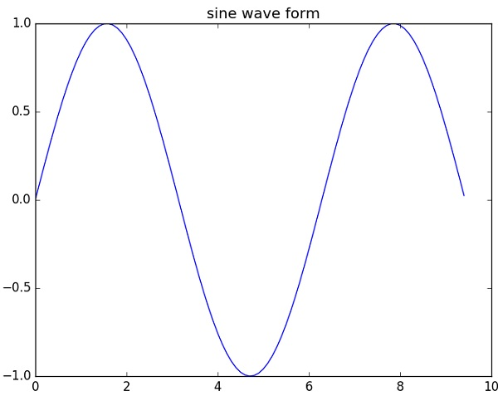

Bar Plots:
For labeled, non-time series data, you may wish to produce a bar plot:
In [15]: plt.figure();
In [16]: df.iloc[5].plot.bar(); plt.axhline(0, color='k')
Out[16]: <matplotlib.lines.Line2D at 0x135da0588>
Calling a DataFrame’s plot.bar() method produces a multiple bar plot:
In [17]: df2 = pd.DataFrame(np.random.rand(10, 4), columns=['a', 'b', 'c', 'd'])
In [18]: df2.plot.bar();
To produce a stacked bar plot, pass stacked=True:
In [19]: df2.plot.bar(stacked=True);
To get horizontal bar plots, use the barh method:
In [20]: df2.plot.barh(stacked=True);

Histograms
Histogram can be drawn by using the DataFrame.plot.hist() and Series.plot.hist() methods.
In [21]: df4 = pd.DataFrame({'a': np.random.randn(1000) + 1, 'b': np.random.randn(1000),
....: 'c': np.random.randn(1000) - 1}, columns=['a', 'b', 'c'])
....:
In [22]: plt.figure();
In [23]: df4.plot.hist(alpha=0.5)
Out[23]: <matplotlib.axes._subplots.AxesSubplot at 0x136364da0>
Histogram can be stacked by stacked=True. Bin size can be changed by bins keyword.
In [24]: plt.figure();
In [25]: df4.plot.hist(stacked=True, bins=20)
Out[25]: <matplotlib.axes._subplots.AxesSubplot at 0x136353390>
The existing interface DataFrame.hist to plot histogram still can be used.
In [28]: plt.figure();
In [29]: df['A'].diff().hist()
Out[29]: <matplotlib.axes._subplots.AxesSubplot at 0x1369e4a90>
DataFrame.hist() plots the histograms of the columns on multiple subplots:
In [30]: plt.figure()
Out[30]: <Figure size 640x480 with 0 Axes>
In [31]: df.diff().hist(color='k', alpha=0.5, bins=50)
Out[31]:
array([[<matplotlib.axes._subplots.AxesSubplot object at 0x136b7e5c0>,
<matplotlib.axes._subplots.AxesSubplot object at 0x136bb21d0>],
[<matplotlib.axes._subplots.AxesSubplot object at 0x136be4e80>,
<matplotlib.axes._subplots.AxesSubplot object at 0x136c22a20>]], dtype=object)

Pie plot
You can create a pie plot with DataFrame.plot.pie() or Series.plot.pie(). If your data includes any NaN, they will be automatically filled with 0. A ValueError will be raised if there are any negative values in your data.
In [73]: series = pd.Series(3 * np.random.rand(4), index=['a', 'b', 'c', 'd'], name='series')

In [74]: series.plot.pie(figsize=(6, 6))
Out[74]: <matplotlib.axes._subplots.AxesSubplot at 0x114fc5518>
For pie plots it’s best to use square figures, one’s with an equal aspect ratio. You can create the figure with equal width and height, or force the aspect ratio to be equal after plotting by calling ax.set_aspect('equal') on the returned axes object.
Note that pie plot with DataFrame requires that you either specify a target column by the y argument or subplots=True. When y is specified, pie plot of selected column will be drawn. If subplots=True is specified, pie plots for each column are drawn as subplots. A legend will be drawn in each pie plots by default; specify legend=False to hide it.
In [75]: df = pd.DataFrame(3 * np.random.rand(4, 2), index=['a', 'b', 'c', 'd'], columns=['x', 'y'])
In [76]: df.plot.pie(subplots=True, figsize=(8, 4))
Out[76]:
array([<matplotlib.axes._subplots.AxesSubplot object at 0x130db1f98>,
<matplotlib.axes._subplots.AxesSubplot object at 0x12da33710>], dtype=object)

# Importing libraries
import matplotlib.pyplot as plt
import numpy as np
import pandas as pd

# Plotting a Line
plt.plot([1,2,3,4], [1,2,3,4])
plt.xlabel('Some numbers')
plt.ylabel('Some more numbers')
plt.show()

# Plotting using X axis only
plt.plot([4,3,8,9])
plt.xlabel('Some numbers')
plt.ylabel('Some more numbers')
plt.show()

# Plotting with Tweaking Colors and Symbols
plt.plot([1,2,6,8], [9,16,2,3], 'c')
plt.xlabel('Some numbers')
plt.ylabel('Some more numbers')
plt.show()

plt.plot([1,2,6,8], [9,16,2,3], 'm+')
plt.xlabel('Some numbers')
plt.ylabel('Some more numbers')
plt.show()

# red dashes, blue squares and green triangles
t = np.arange(0., 5., 0.2)

plt.plot(t, t, 'r--', t, t**2, 'bs', t, t**3, 'g^')
plt.show()

# ------ By using Formula

data = np.arange(0, 10, 0.5)
y = 1 * data + 5
plt.plot(data, y, '*')
plt.show()

# ------- By Dictionary, Color and Size
data = {
'a': np.arange(50),
'color': np.random.randint(0, 50, 50),
'size': np.random.randn(50)
}
data['b'] = data['a'] + 10 * np.random.randn(50)
data['size'] = np.abs(data['size']) * 100

plt.scatter('a', 'b', c = 'color', s = 'size', data=data)
plt.xlabel('Entries for A')
plt.ylabel('Entries of B')
plt.show()

# ------- Plotting with Categorical Data
names = ['GroupA', 'GroupB', 'GroupC']
values = [1, 10, 100]

plt.figure(1, figsize=(10,4))

plt.subplot(131)
plt.bar(names, values)
plt.subplot(132)
plt.scatter(names,values)
plt.subplot(133)
plt.plot(names, values)
plt.suptitle('Categorical Plotting')
plt.show()

# -------- Plotting over 3D Axes
import matplotlib as mpl
from mpl_toolkits.mplot3d import Axes3D

mpl.rcParams['legend.fontsize'] = 10
fig = plt.figure()
ax = fig.add_subplot(111, projection='3d')

# -------- Parametric Curve

mpl.rcParams['legend.fontsize'] = 10
fig = plt.figure()
ax = fig.gca(projection='3d')
theta = np.linspace(-4 * np.pi, 4 * np.pi, 100)

z = np.linspace(-2, 2, 100)
r = z**2 + 1
x = r * np.sin(theta)
y = r * np.cos(theta)

ax.plot(x, y, z, label='Parametric Curve')
ax.legend()
plt.show()

# --------- Simple Trignometry plots

x = np.arange(1, 5 * np.pi, 0.01)
y = np.sin(x)
plt.title('Sine Wave')
plt.plot(x, y)
plt.show()

# ---------- Subplots of Sine and Cosine
x = np.arange(0, 3* np.pi, 0.1)
y_sin = np.sin(x)
y_cos = np.cos(x)

plt.subplot(1, 2, 1)
plt.plot(x, y_sin)
plt.title('Sine Wave')

plt.subplot(1, 2, 2)
plt.plot(x, y_cos)
plt.title('Cosine Wave')
plt.suptitle('Waveforms')
plt.show()

# ------- Plotting of Histogram
a = np.array([22, 87, 5, 43, 56, 73, 55, 54, 11, 20, 51, 5, 79, 31, 27])
plt.hist(a, bins=[0, 20, 40, 60, 80, 100])
plt.show()

# ------- Plotting using BAR Graph
x1 = [5, 8, 10]
y1 = [12, 16, 6]

x2 = [6, 9, 11]
y2 = [6, 15, 7]

plt.bar(x1, y1, color = 'b')
plt.bar(x2, y2, color = 'g', align='center')

plt.title('Bar Graph')
plt.ylabel('Y Axis')
plt.xlabel('X Axis')
plt.show()

# ----------- PIE Chart Plotting

labels = ['Politics', 'Science', 'History', 'Heritage']
interest = [15, 30, 45, 10]

fig1, ax1 = plt.subplots()
ax1.pie(interest, labels=labels)
plt.show()

# ------------ MATPLOTLIB with PANDAS

ds1 = pd.read_csv('1_WaterWellDev.csv')
ds1.plot()
ds1 = ds1.dropna()
ds1.plot.bar(subplots=True)
ds1.plot.bar(stacked=True)

ds1 = ds1.T
ds1.iloc[1:, :].plot()
ds1.plot.box()

G.H.RAISONI COLLEGE OF ENGINEERING, WAGHOLI, PUNE

DEPARTMENT OF COMPUTER ENGINEERING
ASSIGNMENT NUMBER 6

TITLE:
Dataset selection: Dataset for Classification / Regression / Associative Rule Mining. and Analysis: Independent Variables, Dependent Variables, Handling Missing Values, Categorical data, and Feature Scaling

Importing Data with read_csv()
The first step to any data science project is to import your data. Often, you'll work with data in Comma Separated Value (CSV) files and run into problems at the very start of your workflow. In this tutorial, you'll see how you can use the read_csv() function from pandas to deal with common problems when importing data and see why loading CSV files specifically with pandas has become standard practice for working data scientists today.

The filesystem
Before you can use pandas to import your data, you need to know where your data is in your filesystem and what your current working directory is. You'll see why this is important very soon, but let's review some basic concepts:
Everything on the computer is stored in the filesystem. "Directories" is just another word for "folders", and the "working directory" is simply the folder you're currently in. Some basic Shell commands to navigate your way in the filesystem:
- The ls command lists all content in the current working directory.
- The cd command followed by:
  - the name of a sub-directory allows you to change your working directory to the sub-directory you specify.
  - .. allows you to navigate back to the parent directory of your current working directory.
- The pwd command prints the path of your current working directory.
IPython allows you to execute Shell commands directly from the IPython console via its magic commands. Here are the ones that correspond to the commands you saw above:
- ! ls in IPython is the same as ls in the command line.
- %cd in IPython is the same as cd in the command line.
- ! pwd in IPython is the same as pwd in the command line. The working directory is also printed after changing into it in IPython, which isn't the case in the command line.
In your filesystem, there's a file called cereal.csv that contains nutrition data on 80 cereals. Enter the magic commands one-by-one in the IPython Shell, and see if you can locate the dataset!

Loading your data
Now that you know what your current working directory is and where the dataset is in your filesystem, you can specify the file path to it. You're now ready to import the CSV file into Python using read_csv() from pandas:
import pandas as pd
cereal_df = pd.read_csv("/tmp/tmp07wuam09/data/cereal.csv")
cereal_df2 = pd.read_csv("data/cereal.csv")

# Are they the same?
print(pd.DataFrame.equals(cereal_df, cereal_df2))

True

Feature Selection for Machine Learning
This section lists 4 feature selection recipes for machine learning in Python
This post contains recipes for feature selection methods.
1. Univariate Selection
Statistical tests can be used to select those features that have the strongest relationship with the output variable.
The scikit-learn library provides the SelectKBest class that can be used with a suite of different statistical tests to select a specific number of features.
2. Recursive Feature Elimination
The Recursive Feature Elimination (or RFE) works by recursively removing attributes and building a model on those attributes that remain.
It uses the model accuracy to identify which attributes (and combination of attributes) contribute the most to predicting the target attribute.
3. Principal Component Analysis
Principal Component Analysis (or PCA) uses linear algebra to transform the dataset into a compressed form.
Generally this is called a data reduction technique. A property of PCA is that you can choose the number of dimensions or principal component in the transformed result.
4. Feature Importance
Bagged decision trees like Random Forest and Extra Trees can be used to estimate the importance of features.

Feature Scaling
Feature scaling is the method to limit the range of variables so that they can be compared on common grounds. It is performed on continuous variables. Lets plot the distribution of all the continuous variables in the data set.
>> import matplotlib.pyplot as plt
>> X_train[X_train.dtypes[(X_train.dtypes=="float64")|(X_train.dtypes=="int64")]
.index.values].hist(figsize=[11,11])

Data Preprocessing:
Data Preprocessing for Machine learning in Python
- Pre-processing refers to the transformations applied to our data before feeding it to the algorithm.
- Data Preprocessing is a technique that is used to convert the raw data into a clean data set. In other words, whenever the data is gathered from different sources it is collected in raw format which is not feasible for the analysis.
Need of Data Preprocessing
• For achieving better results from the applied model in Machine Learning projects the format of the data has to be in a proper manner. Some specified Machine Learning model needs information in a specified format, for example, Random Forest algorithm does not support null values, therefore to execute random forest algorithm null values have to be managed from the original raw data set.
• Another aspect is that data set should be formatted in such a way that more than one Machine Learning and Deep Learning algorithms are executed in one data set, and best out of them is chosen.

Get the Dataset:
- In any Machine Learning Model, we are going to use some independent variables to predict the dependent variables
- Example as per the Data.csv
Importing the Libraries and Dataset
Library is a tool that you can use to make a specific job. You just have to give some inputs then the library will do job for you & it returns the output that you exactly looking for
import numpy as np
import matplotlib.pyplot as plt
import pandas as pd
Missing Data
- Method1: Remove the lines or observations of missing data
- Dangerous?
- Method2: Averaging/Mean: Take the mean of columns and place the missing value by mean of all columns
- Imputer class allows us to take out the missing data and transform replaces the missing values by mean of columns
Categorical Data:
- Since machine learning models are based on mathematical equations, it will cause some problem if we keep text in the categorical variables in the equations. As we want only numbers in the equation, encode the text into numbers
- As 1>0 & 2>1, the equation in the model thinks that e.g. Spain has higher value than Germany & France & Germany has higher value than France.
- As there is no relational order, we have to prevent the machine learning equation from thinking this
- To prevent this, dummy variables are used. Instead of one column, we have three columns and no. of columns=no of categories
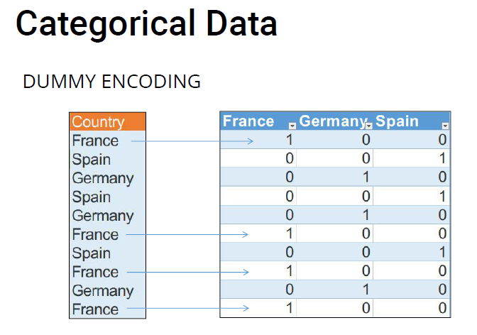

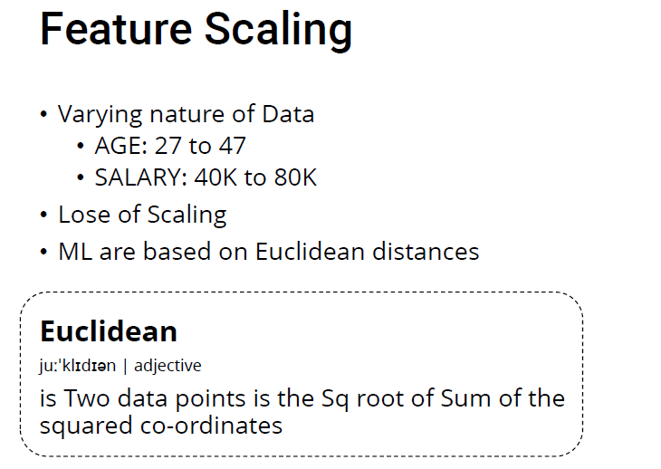

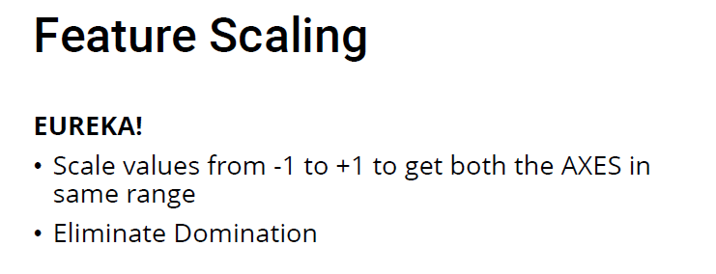

Program:

# Data Pre-Processing
# IMPORT LIBRARIES
import numpy as np
import matplotlib.pyplot as plt
import pandas as pd

# IMPORTING DATASET
dataset = pd.read_csv("LinearRegression/Data.csv")
X = dataset.iloc[:, :-1].values
y = dataset.iloc[:, 3].values

print("FIRST X ___\n", X)
print("FIRST y ___\n", y)

# Taking care of Missing Data
from sklearn.preprocessing import Imputer

imputer = Imputer(missing_values= 'NaN', strategy='mean', axis = 0)
imputer1 = imputer.fit(X[:, 1:3])
X[:, 1:3] = imputer.transform(X[:, 1:3])

print("IMPUTED X ____\n",X)

# Encoding Categorical data
from sklearn.preprocessing import LabelEncoder, OneHotEncoder

labelencoder_X = LabelEncoder()
X[:, 0] = labelencoder_X.fit_transform(X[:, 0])
# Learn the Output
# PROBLEM for Country & Purchase
# France > Spain > Germany! Well... WTH is that!

print("TRANSFORMED X____\n",X)

# Solution
# COUNTRY
onehotencoder = OneHotEncoder(categorical_features= [0])
X = onehotencoder.fit_transform(X).toarray()
# PURCHASE
labelencoder_y = LabelEncoder()
y = labelencoder_y.fit_transform(y)

print("CATEGORICAL y",y)

# Splitting Data into Training & Testing
from sklearn.cross_validation import train_test_split
X_train, X_test, y_train, y_test = train_test_split(X, y, test_size = 0.2, random_state = 0)

print("PRE-SCALED VALUES")
print(X_train)
print(X_test)
print("_"*40)
print(y_train)
print(y_test)

# Feature Scaling
from sklearn.preprocessing import StandardScaler
sc_X = StandardScaler()
X_train = sc_X.fit_transform(X_train)
X_test = sc_X.transform(X_test)

print("POST-SCALED VALUES")
print(X_train)
print(X_test)
# DO YOU NEED TO SCALE DUMMY VARIABLES?
# IT DEPENDS on your models
# DO YOU NEED TO SCALE Y Variables?
# NO, Cz IT is a dependent variable

G.H.RAISONI COLLEGE OF ENGINEERING, WAGHOLI, PUNE

DEPARTMENT OF COMPUTER ENGINEERING
ASSIGNMENT NUMBER 7

Aim: Regression: Performing Simple Linear Regression over a salary dataset and predict salaries according to their experience years
Learning Objective: To learn and implement simple linear regression
Theory:
Linear regression is a statistical approach for modelling relationship between a dependent variable with a given set of independent variables.

Simple Linear Regression
Simple linear regression is an approach for predicting a response using a single feature.
It is assumed that the two variables are linearly related. Hence, we try to find a linear function that predicts the response value(y) as accurately as possible as a function of the feature or independent variable(x).
Let us consider a dataset where we have a value of response y for every feature x:

For generality, we define:
x as feature vector, i.e x = [x_1, x_2, …., x_n],
y as response vector, i.e y = [y_1, y_2, …., y_n]
for n observations (in above example, n=10).
A scatter plot of above dataset looks like:-

Now, the task is to find a line which fits best in above scatter plot so that we can predict the response for any new feature values. (i.e a value of x not present in dataset)
This line is called regression line.
The equation of regression line is represented as:

Here,
- h(x_i) represents the predicted response value for ith observation.
- b_0 and b_1 are regression coefficients and represent y-intercept and slope of regression line respectively.
To create our model, we must “learn” or estimate the values of regression coefficients b_0 and b_1. And once we’ve estimated these coefficients, we can use the model to predict responses
Get the Dataset:
- Find out the correlation between salary & years of experience
- For this we will create a model i.e. Simple Linear Regression Model which will tell us what is the best fitting line for this relationship
Y = b0 + b1*X1

What is Regression ? How does it work ?
Regression is a parametric technique used to predict continuous (dependent) variable given a set of independent variables. It is parametric in nature because it makes certain assumptions (discussed next) based on the data set. If the data set follows those assumptions, regression gives incredible results. Otherwise, it struggles to provide convincing accuracy. Don't worry. There are several tricks (we'll learn shortly) we can use to obtain convincing results.
Mathematically, regression uses a linear function to approximate (predict) the dependent variable given as:
Y = βo + β1X + ∈
where, Y - Dependent variable
X - Independent variable
βo - Intercept
β1 - Slope
∈ - Error
βo and β1 are known as coefficients. This is the equation of simple linear regression. It's called 'linear' because there is just one independent variable (X) involved. In multiple regression, we have many independent variables (Xs). If you recall, the equation above is nothing but a line equation (y = mx + c) we studied in schools. Let's understand what these parameters say:
Y - This is the variable we predict
X - This is the variable we use to make a prediction
βo - This is the intercept term. It is the prediction value you get when X = 0
β1 - This is the slope term. It explains the change in Y when X changes by 1 unit. ∈ - This represents the residual value, i.e. the difference between actual and predicted values.
Error is an inevitable part of the prediction-making process. No matter how powerful the algorithm we choose, there will always remain an (∈) irreducible error which reminds us that the "future is uncertain."
Yet, we humans have a unique ability to persevere, i.e. we know we can't completely eliminate the (∈) error term, but we can still try to reduce it to the lowest. Right? To do this, regression uses a technique known as Ordinary Least Square(OLS).
So the next time when you say, I am using linear /multiple regression, you are actually referring to the OLS technique. Conceptually, OLS technique tries to reduce the sum of squared errors ∑[Actual(y) - Predicted(y')]² by finding the best possible value of regression coefficients (β0, β1, etc).
Is OLS the only technique regression can use? No! There are other techniques such as Generalized Least Square, Percentage Least Square, Total Least Squares, Least absolute deviation, and many more. Then, why OLS? Let's see.
- It uses squared error which has nice mathematical properties, thereby making it easier to differentiate and compute gradient descent.
- OLS is easy to analyze and computationally faster, i.e. it can be quickly applied to data sets having 1000s of features.
- Interpretation of OLS is much easier than other regression techniques.
Let's understand OLS in detail using an example:
We are given a data set with 100 observations and 2 variables, namely Heightand Weight. We need to predict weight(y) given height(x1). The OLS equation can we written as:
Y = βo + β1(Height)+ ∈
When using R, Python or any computing language, you don't need to know how these coefficients and errors are calculated. As a matter of fact, most people don't care. But you must know, and that's how you'll get close to becoming a master.
The formula to calculate these coefficients is easy. Let's say you are given the data, and you don't have access to any statistical tool for computation. Can you still make any prediction? Yes!
The most intuitive and closest approximation of Y is mean of Y, i.e. even in the worst case scenario our predictive model should at least give higher accuracy than mean prediction. The formula to calculate coefficients goes like this:
β1 = Σ(xi - xmean)(yi-ymean)/ Σ (xi - xmean)² where i= 1 to n (no. of obs.)

βo = ymean - β1(xmean)
Now you know ymean plays a crucial role in determining regression coefficients and furthermore accuracy. In OLS, the error estimates can be divided into three parts:
Residual Sum of Squares (RSS) - ∑[Actual(y) - Predicted(y)]²
Explained Sum of Squares (ESS) - ∑[Predicted(y) - Mean(ymean)]²
Total Sum of Squares (TSS) - ∑[Actual(y) - Mean(ymean)]²
The most important use of these error terms is used in the calculation of the Coefficient of Determination (R²).
`R² = 1 - (SSE/TSS)`
R² metric tells us the amount of variance explained by the independent variables in the model. In the upcoming section, we'll learn and see the importance of this coefficient and more metrics to compute the model's accuracy.

What are the assumptions made in regression ?
As we discussed above, regression is a parametric technique, so it makes assumptions. Let's look at the assumptions it makes:
- There exists a linear and additive relationship between dependent (DV) and independent variables (IV). By linear, it means that the change in DV by 1 unit change in IV is constant. By additive, it refers to the effect of X on Y is independent of other variables.
- There must be no correlation among independent variables. Presence of correlation in independent variables lead to Multicollinearity. If variables are correlated, it becomes extremely difficult for the model to determine the true effect of IVs on DV.
- The error terms must possess constant variance. Absence of constant variance leads to heteroskedestacity.
- The error terms must be uncorrelated i.e. error at ∈t must not indicate the at error at ∈t+1. Presence of correlation in error terms is known as Autocorrelation. It drastically affects the regression coefficients and standard error values since they are based on the assumption of uncorrelated error terms.
- The dependent variable and the error terms must possess a normal distribution.
Presence of these assumptions make regression quite restrictive. By restrictive I meant, the performance of a regression model is conditioned on fulfillment of these assumptions.
Steps:
Prepare your data preprocessing template
Co-relate salaries with experience
Carry out prediction
Verify the values of prediction
Prediction on test set

Program:

# Simple Linear Regression

# Importing the libraries
import numpy as np
import matplotlib.pyplot as plt
import pandas as pd

# Importing the dataset
dataset = pd.read_csv('Salary_Data.csv')
X = dataset.iloc[:, :-1].values
y = dataset.iloc[:, 1].values

# Splitting the dataset into the Training set and Test set
from sklearn.cross_validation import train_test_split
X_train, X_test, y_train, y_test = train_test_split(X, y, test_size = 1/3, random_state = 0)

# Feature Scaling
from sklearn.preprocessing import StandardScaler
sc_X = StandardScaler()
X_train = sc_X.fit_transform(X_train)
X_test = sc_X.transform(X_test)
sc_y = StandardScaler()
y_train = sc_y.fit_transform(y_train)"""

# Fitting Simple Linear Regression to the Training set
from sklearn.linear_model import LinearRegression
regressor = LinearRegression()
regressor.fit(X_train, y_train)

# Predicting the Test set results
y_pred = regressor.predict(X_test)

# Visualising the Training set results
plt.scatter(X_train, y_train, color = 'red')
plt.plot(X_train, regressor.predict(X_train), color = 'blue')
plt.title('Salary vs Experience (Training set)')
plt.xlabel('Years of Experience')
plt.ylabel('Salary')
plt.show()

# Visualising the Test set results
plt.scatter(X_test, y_test, color = 'red')
plt.plot(X_train, regressor.predict(X_train), color = 'blue')
plt.title('Salary vs Experience (Test set)')
plt.xlabel('Years of Experience')
plt.ylabel('Salary')
plt.show()

G.H.RAISONI COLLEGE OF ENGINEERING, WAGHOLI, PUNE

DEPARTMENT OF COMPUTER ENGINEERING
ASSIGNMENT NUMBER 8

Aim: Regression & Data Valuation: Performing Multi-linear Regression (using appropriate Model) to evaluate with data which is useful for model training

Learning Objective: To learn and implement Multi-linear Regression

Theory:

Multiple Linear Regression
Multiple Linear Regression is a type of Linear Regression when the input has multiple features (variables).

An extension of simple linear regression
In simple linear regression there is a one-to-one relationship between the input variable and the output variable. But in multiple linear regression, as the name implies there is a many-to-one relationship, instead of just using one input variable, you use several.

New considerations
Adding more input variables does not mean the regression will be better, or offer better predictions. Multiple and simple linear regression have different use cases, one is not superior. In some cases adding more input variables can make things worse, this is referred to as over-fitting.

Multicollinearity
When you add more input variables it creates relationships among them. So not only are the input variables potentially related to the output variable, they are also potentially related to each other, this is referred to as multicollinearity. The optimal scenario is for all of the input variables to be correlated with the output variable, but not with each other.

The model
The model for multiple linear regression is as you would expect, very similar to the one for simple linear regression. It goes as follows:
f(X) = a + (B1 * X1) + (B2 * X2) … + (Bp * Xp).
Where X is the input variables and Xp is a specific input variable, Bp is the coefficient (slope) of the input variable Xp and a is the intercept. Let’s test this out with an example!

Preparation before doing multiple regression
- Collect a list of potential input variables and a potential output variable.
- Collect data on the variables.
- check the correlation between each input variable and the output variable.
- Check the correlation among the input variables.
- Use the non-redundant input variables in the analysis to find the best fitting model.
Program:

# Multiple Linear Regression

# Importing the libraries
import numpy as np
import matplotlib.pyplot as plt
import pandas as pd

# Importing the dataset
dataset = pd.read_csv('50_Startups.csv')
X = dataset.iloc[:, :-1].values
y = dataset.iloc[:, 4].values

# Encoding categorical data
from sklearn.preprocessing import LabelEncoder, OneHotEncoder
labelencoder = LabelEncoder()
X[:, 3] = labelencoder.fit_transform(X[:, 3])
onehotencoder = OneHotEncoder(categorical_features = [3])
X = onehotencoder.fit_transform(X).toarray()

# Avoiding the Dummy Variable Trap
X = X[:, 1:]

# Splitting the dataset into the Training set and Test set
from sklearn.cross_validation import train_test_split
X_train, X_test, y_train, y_test = train_test_split(X, y, test_size = 0.2, random_state = 0)

# Feature Scaling
"""from sklearn.preprocessing import StandardScaler
sc_X = StandardScaler()
X_train = sc_X.fit_transform(X_train)
X_test = sc_X.transform(X_test)
sc_y = StandardScaler()
y_train = sc_y.fit_transform(y_train)"""

# Fitting Multiple Linear Regression to the Training set
from sklearn.linear_model import LinearRegression
regressor = LinearRegression()
regressor.fit(X_train, y_train)

# Predicting the Test set results
y_pred = regressor.predict(X_test)

G.H.RAISONI COLLEGE OF ENGINEERING, WAGHOLI, PUNE

DEPARTMENT OF COMPUTER ENGINEERING
ASSIGNMENT NUMBER 9

Aim: Regression: Using Polynomial regression resolve bluff query for new employee salary

Learning Objective: To learn and implement polynomial regression

Theory:
Polynomial regression

polynomial regression, a special case of multiple linear regression that adds terms with degrees greater than one to the model. The real-world curvilinear relationship is captured when you transform the training data by adding polynomial terms, which are then fit in the same manner as in multiple linear regression.
Historically, polynomial models are among the most frequently used empirical models for fitting functions. These models are popular for the following reasons: • In mathematical analysis, the Weierstrass approximation theorem states that every continuous function defined on an interval [a,b] can be uniformly approximated as closely as desired by a polynomial function. They have a simple form, and well known and understood properties. They have a moderate flexibility of shapes, and they are computationally easy to use.
• Polynomial functions are a closed family. Linear transformations in the data result in a polynomial model being mapped to another polynomial model. That means that the polynomial models are not dependent on the underlying metric. Polynomial models also have the following limitations:
• Polynomial models have poor interpolatory and extrapolatory properties. High-degree polynomials are known for oscillation at the edges of an interval3 producing poor interpolatory properties. While polynomials may provide good fits within the range of data, the degree of fit frequently deteriorates rapidly outside the range of the data resulting in poor extrapolatory properties.
• Polynomial models have poor asymptotic properties. They have a finite response for finite values and have an infinite response if some variable takes an infinite value. Thus polynomials may not model asymptotic phenomena very well.
• Polynomial models have a shape/degree tradeoff. In order to model data with a complicated structure, the degree of the model must be high, indicating that the associated number of parameters to be estimated will also be high. This can result in highly unstable models. Polynomial regression is a form of linear regression in which the relationship between the input variables x and the output variable y is modeled as a polynomial. Although polynomial regression fits a nonlinear model to the data, as a statistical estimation problem it is linear, in the sense that the regression function is linear in the unknown parameters that are estimated from the data. For this reason, polynomial regression is considered to be a special case of linear regression.

Polynomial regression comes into play when your correlation of data is nonlinear and thus a linear model type isn’t fitting anymore. Rather than using a straight line, so a linear model to estimate the predictions, it could be for instance a quadratic model or cubic model with a curved line. Polynomial regression is a form of linear regression that allows you to predict a single y variable by decomposing the x variable into a n-th order polynomial. It can have any form of the following function for the hypothesis function.
h(x) => thetaZero + thetaOne * x + thetaTwo * x^2 + thetaThree * x^3 ..... thetaK * x^k
As the successive powers of x are added to the equation, the regression line changes its shape. By selecting a fitting model type, you can reduce your costs over time by a significant amount. In the following diagram, the regression line is better fitting than the previously linear regression line.
Price +
| XX
| XXXXXXX 0
| 0 XX 0
| 0 XXXXXXX
| | XX
| XXXXXXX
| 0X 0
| 0 XXXXXX
| | XX|
| 0 | XXXXX 0
| | XX
| XXXX
|XX
+-------------------------------------------------+
Size
Polynomial regression can reduce your costs returned by the cost function. It gives your regression line a curvilinear shape and makes it more fitting for your underlying data. By applying a higher order polynomial, you can fit your regression line to your data more precisely. But isn’t there any problem with the approach of using more complex polynomials to perfectly fit the regression line?

Over-fitting in Polynomial Regression
There is one crucial aspect when using polynomial regression. By selecting models for your regression problem, you want to determine which of these models is the most parsimonious. What does a parsimonious model mean? Generally speaking, you need to care more about a parsimony model rather than a best-fitting model. A complex model could over-fit your data. It becomes an over-fitting problemor in other words the algorithm has a high variance. For instance, you might find that a quadratic model fits your trainings set reasonably well. On the other hand, you find out about a very high order polynomial that goes almost perfectly through each of your data points.
Price + XXX
| X X
| XX X X0
| X X0 X0 X
| 0 X X X
| |X X X
| XX X XXX
| XXX X 0 X0
| 0 X X X X
| X X X XX
| 0 X 0
| X XXX
|X
|
+-------------------------------------------------+
Size
Even though this model fits perfectly, it will be terrible at making future predictions. It fits the data too well, so it’s over-fitting. It’s about balancing the model’s complexity with the model’s explanatory power. That’s a parsimonious model. It is a model that accomplishes a desired level of explanation or prediction with as few predictor variables as possible. In conclusion, you want to have a best-fitting prediction when using low order polynomials. There is no point in finding the best-fitting regression line that fits all of your data points.
Conclusion: Thus we have studied the implementation of polynomial regression algorithm using python.
Program:
# POLYNOMIAL LINEAR REGRESSION
# IMPORT LIBRARIES
import numpy as np
import matplotlib.pyplot as plt
import pandas as pd

# IMPORTING DATASET
dataset = pd.read_csv("1_Regression/Position_Salaries.csv")
X = dataset.iloc[:, 1:2].values
y = dataset.iloc[:, 2].values

# Splitting Data into Training & Testing
# WE WILL NOT SPLIT DATA HERE Since the size of dataset is very small
# and that'll be ridiculous to do that with distinct values

# Fitting Linear Regression to the Dataset
from sklearn.linear_model import LinearRegression
lin_reg = LinearRegression()
lin_reg.fit(X, y)

# Fitting Polynomial Regression to the Dataset
from sklearn.preprocessing import PolynomialFeatures
poly_reg = PolynomialFeatures(degree=4)
X_poly = poly_reg.fit_transform(X)

lin_reg_2 = LinearRegression()
d = lin_reg_2.fit(X_poly, y)

# Visualising the Linear Regression results
plt.scatter(X, y, color='red')
plt.plot(X, lin_reg.predict(X), color='black')
plt.title("Truth or Bluff (Linear Regression)")
plt.xlabel("Position Level")
plt.ylabel("Salary")
plt.show()

# Visualising the Polynomial Regression
X_grid = np.arange(min(X), max(X), 0.1)
X_grid = X_grid.reshape(len(X_grid), 1)
plt.scatter(X, y, color='red')
plt.plot(X_grid, lin_reg_2.predict(poly_reg.fit_transform(X_grid)), color='black')
plt.title("<?> Regression")
plt.xlabel("Position Level")
plt.ylabel("Salary")
plt.show()

# Predicting a new Result with Linear Regression
o = lin_reg.predict(X =6.5)

# Predictig a new Result with Polynomial Regression
o1 = lin_reg_2.predict(poly_reg.fit_transform(6.5))

G.H.RAISONI COLLEGE OF ENGINEERING, WAGHOLI, PUNE
DEPARTMENT OF COMPUTER ENGINEERING

Assignment no.10
Aim: Classification: Use KNN (with WCSS) to Predict if a customer with certain age and Salary will purchase a product or not
Learning Objective: To study classification algorithms
Theory:

When do we use KNN algorithm?
KNN can be used for both classification and regression predictive problems. However, it is more widely used in classification problems in the industry. To evaluate any technique we generally look at 3 important aspects:
1. Ease to interpret output
2. Calculation time
3. Predictive Power
Let us take a few examples to place KNN in the scale :
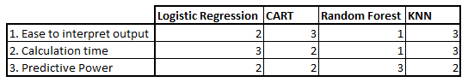

KNN algorithm fairs across all parameters of considerations. It is commonly used for its easy of interpretation and low calculation time.

How does the KNN algorithm work?
Let’s take a simple case to understand this algorithm. Following is a spread of red circles (RC) and green squares (GS):
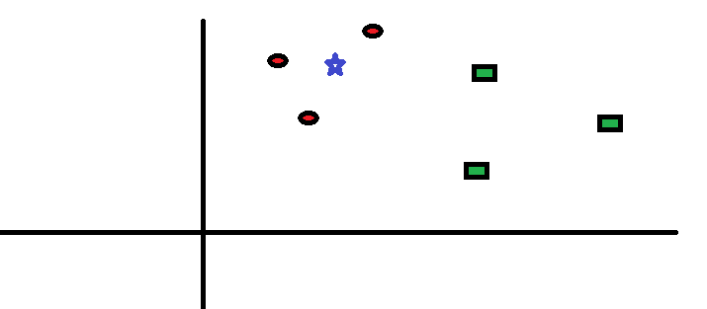

You intend to find out the class of the blue star (BS) . BS can either be RC or GS and nothing else. The “K” is KNN algorithm is the nearest neighbors we wish to take vote from. Let’s say K = 3. Hence, we will now make a circle with BS as center just as big as to enclose only three datapoints on the plane. Refer to following diagram for more details:

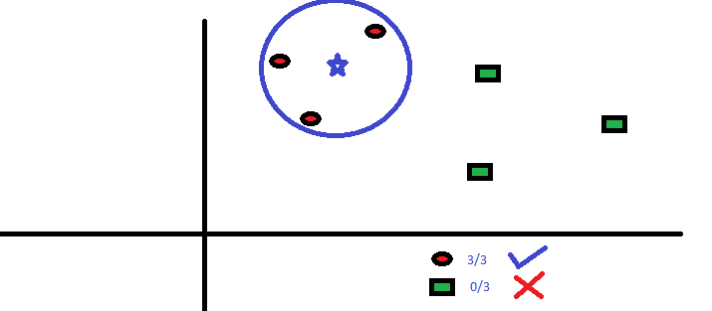

The three closest points to BS is all RC. Hence, with good confidence level we can say that the BS should belong to the class RC. Here, the choice became very obvious as all three votes from the closest neighbor went to RC. The choice of the parameter K is very crucial in this algorithm. Next we will understand what are the factors to be considered to conclude the best K.

How do we choose the factor K?
First let us try to understand what exactly K influences in the algorithm. If we see the last example, given that all the 6 training observation remain constant, with a given K value we can make boundaries of each class. These boundaries will segregate RC from GS. The same way, let’s try to see the effect of value “K” on the class boundaries. Following are the different boundaries separating the two classes with different values of K.
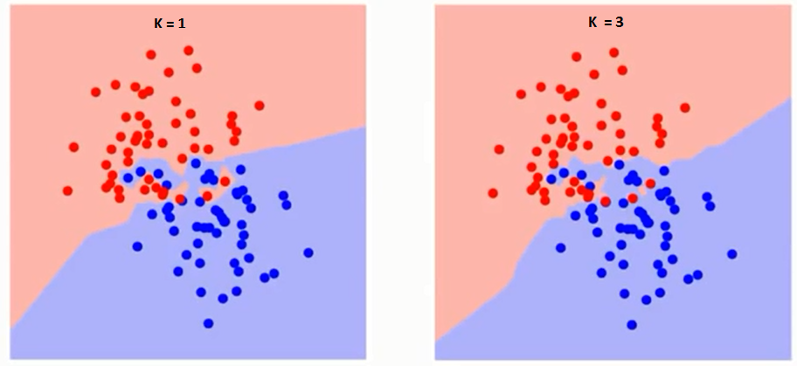

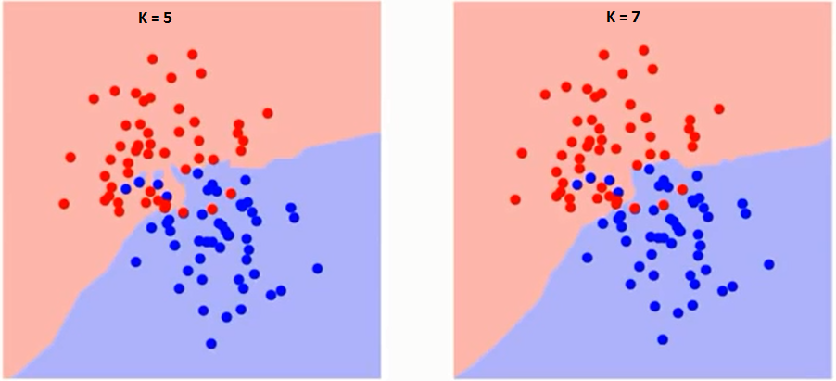

If you watch carefully, you can see that the boundary becomes smoother with increasing value of K. With K increasing to infinity it finally becomes all blue or all red depending on the total majority. The training error rate and the validation error rate are two parameters we need to access on different K-value. Following is the curve for the training error rate with varying value of K:

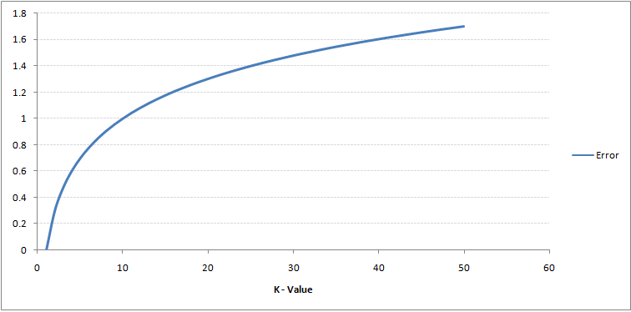
As you can see, the error rate at K=1 is always zero for the training sample. This is because the closest point to any training data point is itself.Hence the prediction is always accurate with K=1. If validation error curve would have been similar, our choice of K would have been 1. Following is the validation error curve with varying value of K:
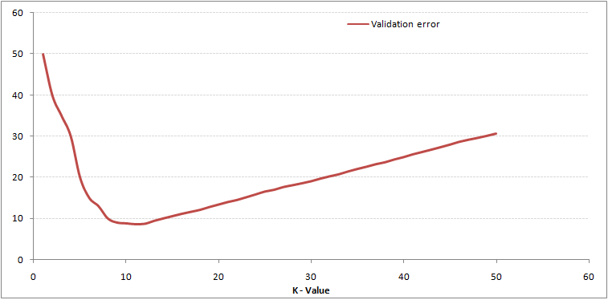
This makes the story more clear. At K=1, we were overfitting the boundaries. Hence, error rate initially decreases and reaches a minima. After the minima point, it then increase with increasing K. To get the optimal value of K, you can segregate the training and validation from the initial dataset. Now plot the validation error curve to get the optimal value of K. This value of K should be used for all predictions.

Breaking it Down – Pseudo Code of KNN
We can implement a KNN model by following the below steps:
- Load the data
- Initialise the value of k
- For getting the predicted class, iterate from 1 to total number of training data points
  - Calculate the distance between test data and each row of training data. Here we will use Euclidean distance as our distance metric since it’s the most popular method. The other metrics that can be used are Chebyshev, cosine, etc.
  - Sort the calculated distances in ascending order based on distance values
  - Get top k rows from the sorted array
  - Get the most frequent class of these rows
  - Return the predicted class
Program:
# K NEAREST NEIGHBORS

# IMPORT LIBRARIES
import numpy as np
import matplotlib.pyplot as plt
import pandas as pd

# IMPORTING DATASET
dataset = pd.read_csv("2_Classification/Social_Network_Ads.csv")
X = dataset.iloc[:, [2, 3]].values
y = dataset.iloc[:, 4].values

# Splitting Data into Training & Testing
from sklearn.model_selection import train_test_split
X_train, X_test, y_train, y_test = train_test_split(X, y, test_size = 0.25, random_state = 0)

# Feature Scaling
from sklearn.preprocessing import StandardScaler
sc_X = StandardScaler()
X_train = sc_X.fit_transform(X_train)
X_test = sc_X.transform(X_test)

# Fitting Classifier to the Training set
from sklearn.neighbors import KNeighborsClassifier
classifier = KNeighborsClassifier(n_neighbors=5, metric='minkowski', p=2)
classifier.fit(X_train, y_train)

# Predicting the Test set results
y_pred = classifier.predict(X_test)

# for i in range(len(y_pred)):
# print(X_test[i, :], y_pred[i])

# Making the Confusion Matrix
from sklearn.metrics import confusion_matrix
cm = confusion_matrix(y_test, y_pred)

# Visualising the Training set results
from matplotlib.colors import ListedColormap
X_set, y_set = X_train, y_train
X1, X2 = np.meshgrid (np.arange (start = X_set[:, 0].min() - 1, stop = X_set[:, 0].max() + 1, step = 0.01),
np.arange (start = X_set[:, 1].min() - 1, stop = X_set[:, 1].max() + 1, step = 0.01))
plt.contourf(X1, X2, classifier.predict(np.array([X1.ravel(), X2.ravel()]).T).reshape(X1.shape),
alpha = 0.75, cmap = ListedColormap(('red', 'green')))
plt.xlim(X1.min(), X1.max())
plt.ylim(X2.min(), X2.max())
for i, j in enumerate(np.unique(y_set)):
plt.scatter(X_set[y_set == j, 0], X_set[y_set == j, 1],
c = ListedColormap(('red', 'green'))(i), label = j)
plt.title ('KNN (Train set)')
plt.xlabel ('Age')
plt.ylabel ('Estimated Salary')
plt.legend ()
plt.show ()

# visualising the Test set results
from matplotlib.colors import ListedColormap
X_set, y_set = X_test, y_test
X1, X2 = np.meshgrid (np.arange(start = X_set[:, 0].min() - 1, stop = X_set[:, 0].max() + 1, step = 0.01),
np.arange(start = X_set[:, 1].min() - 1, stop = X_set[:, 1].max() + 1, step = 0.01))
plt.contourf(X1, X2, classifier.predict (np.array([X1.ravel(), X2.ravel()]).T).reshape(X1.shape),
alpha = 0.75, cmap = ListedColormap(('red', 'green')))
plt.xlim(X1.min(), X1.max())
plt.ylim(X2.min(), X2.max())
for i, j in enumerate(np.unique(y_set)):
plt.scatter (X_set[y_set == j, 0], X_set[y_set == j, 1],
c = ListedColormap(('red', 'green'))(i), label = j)
plt.title ('KNN (Test set)')
plt.xlabel ('Age')
plt.ylabel ('Estimated Salary')
plt.legend ()
plt.show ()

G.H.RAISONI COLLEGE OF ENGINEERING, WAGHOLI, PUNE
DEPARTMENT OF COMPUTER ENGINEERING
Assignment no.11
Aim: Classification: Use Naïve Bayes Classifier to Predict if a customer with certain age and Salary will purchase a product or not
Learning Objective: To study classification algorithms
Theory:
The Naive Bayes algorithm is an intuitive method that uses the probabilities of each attribute belonging to each class to make a prediction. It is the supervised learning approach you would come up with if you wanted to model a predictive modeling problem probabilistically.
Naive bayes simplifies the calculation of probabilities by assuming that the probability of each attribute belonging to a given class value is independent of all other attributes. This is a strong assumption but results in a fast and effective method.
The probability of a class value given a value of an attribute is called the conditional probability. By multiplying the conditional probabilities together for each attribute for a given class value, we have a probability of a data instance belonging to that class.
To make a prediction we can calculate probabilities of the instance belonging to each class and select the class value with the highest probability.
Naive bases is often described using categorical data because it is easy to describe and calculate using ratios. A more useful version of the algorithm for our purposes supports numeric attributes and assumes the values of each numerical attribute are normally distributed (fall somewhere on a bell curve). Again, this is a strong assumption, but still gives robust results.

How Naive Bayes algorithm works?
Let’s understand it using an example. Below I have a training data set of weather and corresponding target variable ‘Play’ (suggesting possibilities of playing). Now, we need to classify whether players will play or not based on weather condition. Let’s follow the below steps to perform it.
Step 1: Convert the data set into a frequency table
Step 2: Create Likelihood table by finding the probabilities like Overcast probability = 0.29 and probability of playing is 0.64.
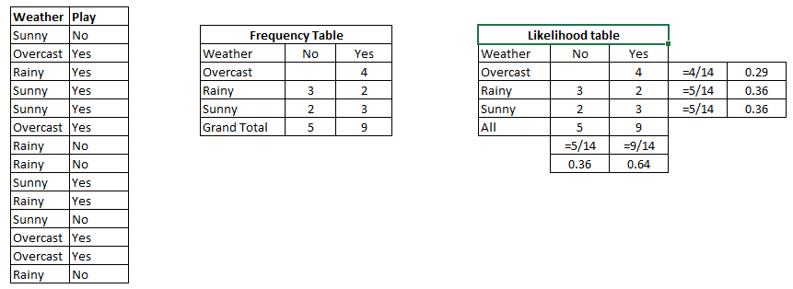
Step 3: Now, use Naive Bayesian equation to calculate the posterior probability for each class. The class with the highest posterior probability is the outcome of prediction.
Problem: Players will play if weather is sunny. Is this statement is correct?
We can solve it using above discussed method of posterior probability.
P(Yes | Sunny) = P( Sunny | Yes) * P(Yes) / P (Sunny)
Here we have P (Sunny |Yes) = 3/9 = 0.33, P(Sunny) = 5/14 = 0.36, P( Yes)= 9/14 = 0.64
Now, P (Yes | Sunny) = 0.33 * 0.64 / 0.36 = 0.60, which has higher probability.
Naive Bayes uses a similar method to predict the probability of different class based on various attributes. This algorithm is mostly used in text classification and with problems having multiple classes.

What are the Pros and Cons of Naive Bayes?
Pros:
- It is easy and fast to predict class of test data set. It also perform well in multi class prediction
- When assumption of independence holds, a Naive Bayes classifier performs better compare to other models like logistic regression and you need less training data.
- It perform well in case of categorical input variables compared to numerical variable(s). For numerical variable, normal distribution is assumed (bell curve, which is a strong assumption).

Cons:
- If categorical variable has a category (in test data set), which was not observed in training data set, then model will assign a 0 (zero) probability and will be unable to make a prediction. This is often known as “Zero Frequency”. To solve this, we can use the smoothing technique. One of the simplest smoothing techniques is called Laplace estimation.
- On the other side naive Bayes is also known as a bad estimator, so the probability outputs from predict_proba are not to be taken too seriously.
- Another limitation of Naive Bayes is the assumption of independent predictors. In real life, it is almost impossible that we get a set of predictors which are completely independent.

4 Applications of Naive Bayes Algorithms
- Real time Prediction: Naive Bayes is an eager learning classifier and it is sure fast. Thus, it could be used for making predictions in real time.
- Multi class Prediction: This algorithm is also well known for multi class prediction feature. Here we can predict the probability of multiple classes of target variable.
- Text classification/ Spam Filtering/ Sentiment Analysis: Naive Bayes classifiers mostly used in text classification (due to better result in multi class problems and independence rule) have higher success rate as compared to other algorithms. As a result, it is widely used in Spam filtering (identify spam e-mail) and Sentiment Analysis (in social media analysis, to identify positive and negative customer sentiments)
- Recommendation System: Naive Bayes Classifier and Collaborative Filtering together builds a Recommendation System that uses machine learning and data mining techniques to filter unseen information and predict whether a user would like a given resource or not

How to build a basic model using Naive Bayes in Python?
Again, scikit learn (python library) will help here to build a Naive Bayes model in Python. There are three types of Naive Bayes model under scikit learn library:
- Gaussian: It is used in classification and it assumes that features follow a normal distribution.
- Multinomial: It is used for discrete counts. For example, let’s say, we have a text classification problem. Here we can consider bernoulli trials which is one step further and instead of “word occurring in the document”, we have “count how often word occurs in the document”, you can think of it as “number of times outcome number x_i is observed over the n trials”.
- Bernoulli: The binomial model is useful if your feature vectors are binary (i.e. zeros and ones). One application would be text classification with ‘bag of words’ model where the 1s & 0s are “word occurs in the document” and “word does not occur in the document” respectively.
Program:
# NAIVE BAYES CLASSIFIER

# IMPORT LIBRARIES
import numpy as np
import matplotlib.pyplot as plt
import pandas as pd

# IMPORTING DATASET
dataset = pd.read_csv("2_Classification/Social_Network_Ads.csv")
X = dataset.iloc[:, [2, 3]].values
y = dataset.iloc[:, 4].values

# Splitting Data into Training & Testing
from sklearn.cross_validation import train_test_split
X_train, X_test, y_train, y_test = train_test_split(X, y, test_size = 0.25, random_state = 0)

# Feature Scaling
from sklearn.preprocessing import StandardScaler
sc_X = StandardScaler()
X_train = sc_X.fit_transform(X_train)
X_test = sc_X.transform(X_test)

# Fitting Logistic Regression to the Training set
from sklearn.naive_bayes import GaussianNB
classifier = GaussianNB()
classifier.fit(X_train, y_train)

# Predicting the Test set results
y_pred = classifier.predict(X_test)

# for i in range(len(y_pred)):
# print(X_test[i, :], y_pred[i])

# Making the Confusion Matrix
from sklearn.metrics import confusion_matrix
cm = confusion_matrix(y_test, y_pred)

# Visualising the Training set results
from matplotlib.colors import ListedColormap
X_set, y_set = X_train, y_train
X1, X2 = np.meshgrid(np.arange(start = X_set[:, 0].min() - 1, stop = X_set[:, 0].max() + 1, step = 0.01),
np.arange(start = X_set[:, 1].min() - 1, stop = X_set[:, 1].max() + 1, step = 0.01))
plt.contourf(X1, X2, classifier.predict(np.array([X1.ravel(), X2.ravel()]).T).reshape(X1.shape),
alpha = 0.75, cmap = ListedColormap(('red', 'green')))
plt.xlim(X1.min(), X1.max())
plt.ylim(X2.min(), X2.max())
for i, j in enumerate(np.unique(y_set)):
plt.scatter(X_set[y_set == j, 0], X_set[y_set == j, 1],
c = ListedColormap(('red', 'green'))(i), label = j)
plt.title('Naive Bayes (Test set)')
plt.xlabel('Age')
plt.ylabel('Estimated Salary')
plt.legend()
plt.show()

# Visualising the Test set results
from matplotlib.colors import ListedColormap
X_set, y_set = X_test, y_test
X1, X2 = np.meshgrid(np.arange(start = X_set[:, 0].min() - 1, stop = X_set[:, 0].max() + 1, step = 0.01),
np.arange(start = X_set[:, 1].min() - 1, stop = X_set[:, 1].max() + 1, step = 0.01))
plt.contourf(X1, X2, classifier.predict(np.array([X1.ravel(), X2.ravel()]).T).reshape(X1.shape),
alpha = 0.75, cmap = ListedColormap(('red', 'green')))
plt.xlim(X1.min(), X1.max())
plt.ylim(X2.min(), X2.max())
for i, j in enumerate(np.unique(y_set)):
plt.scatter(X_set[y_set == j, 0], X_set[y_set == j, 1],
c = ListedColormap(('red', 'green'))(i), label = j)
plt.title('Naive Bayes (Test set)')
plt.xlabel('Age')
plt.ylabel('Estimated Salary')
plt.legend()
plt.show()

G.H.RAISONI COLLEGE OF ENGINEERING, WAGHOLI, PUNE
DEPARTMENT OF COMPUTER ENGINEERING
Assignment no.12
Aim: Classification: Use Decision Tree to Predict if a customer with certain age and Salary will purchase a product or not

Learning Objective: To study classification algorithms

Theory:

Decision Trees in Machine Learning
A tree has many analogies in real life, and turns out that it has influenced a wide area of machine learning, covering both classification and regression. In decision analysis, a decision tree can be used to visually and explicitly represent decisions and decision making. As the name goes, it uses a tree-like model of decisions. Though a commonly used tool in data mining for deriving a strategy to reach a particular goal, its also widely used in machine learning, which will be the main focus of this article.

How can an algorithm be represented as a tree?
For this let’s consider a very basic example that uses titanic data set for predicting whether a passenger will survive or not. Below model uses 3 features/attributes/columns from the data set, namely sex, age and sibsp (number of spouses or children along).
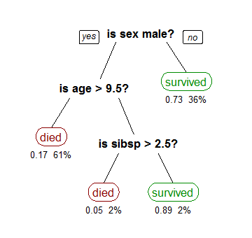
A decision tree is drawn upside down with its root at the top. In the image on the left, the bold text in black represents a condition/internal node, based on which the tree splits into branches/ edges. The end of the branch that doesn’t split anymore is the decision/leaf, in this case, whether the passenger died or survived, represented as red and green text respectively.

Although, a real dataset will have a lot more features and this will just be a branch in a much bigger tree, but you can’t ignore the simplicity of this algorithm. The feature importance is clear and relations can be viewed easily. This methodology is more commonly known as learning decision tree from data and above tree is called Classification tree as the target is to classify passenger as survived or died. Regression trees are represented in the same manner, just they predict continuous values like price of a house. In general, Decision Tree algorithms are referred to as CART or Classification and Regression Trees.
So, what is actually going on in the background? Growing a tree involves deciding on which features to choose and what conditions to use for splitting, along with knowing when to stop. As a tree generally grows arbitrarily, you will need to trim it down for it to look beautiful. Lets start with a common technique used for splitting.

Recursive Binary Splitting

In this procedure all the features are considered and different split points are tried and tested using a cost function. The split with the best cost (or lowest cost) is selected.
Consider the earlier example of tree learned from titanic dataset. In the first split or the root, all attributes/features are considered and the training data is divided into groups based on this split. We have 3 features, so will have 3 candidate splits. Now we will calculate how much accuracy each split will cost us, using a function. The split that costs least is chosen, which in our example is sex of the passenger. This algorithm is recursive in nature as the groups formed can be sub-divided using same strategy. Due to this procedure, this algorithm is also known as the greedy algorithm, as we have an excessive desire of lowering the cost. This makes the root node as best predictor/classifier.

Cost of a split
Lets take a closer look at cost functions used for classification and regression. In both cases the cost functions try to find most homogeneous branches, or branches having groups with similar responses. This makes sense we can be more sure that a test data input will follow a certain path.
Regression : sum(y — prediction)²
Lets say, we are predicting the price of houses. Now the decision tree will start splitting by considering each feature in training data. The mean of responses of the training data inputs of particular group is considered as prediction for that group. The above function is applied to all data points and cost is calculated for all candidate splits. Again the split with lowest cost is chosen. Another cost function involves reduction of standard deviation.
Classification : G = sum(pk * (1 — pk))
A Gini score gives an idea of how good a split is by how mixed the response classes are in the groups created by the split. Here, pk is proportion of same class inputs present in a particular group. A perfect class purity occurs when a group contains all inputs from the same class, in which case pk is either 1 or 0 and G = 0, where as a node having a 50–50 split of classes in a group has the worst purity, so for a binary classification it will have pk = 0.5 and G = 0.5.

When to stop splitting?
You might ask when to stop growing a tree? As a problem usually has a large set of features, it results in large number of split, which in turn gives a huge tree. Such trees are complex and can lead to overfitting. So, we need to know when to stop? One way of doing this is to set a minimum number of training inputs to use on each leaf. For example we can use a minimum of 10 passengers to reach a decision(died or survived), and ignore any leaf that takes less than 10 passengers. Another way is to set maximum depth of your model. Maximum depth refers to the the length of the longest path from a root to a leaf.

Pruning
The performance of a tree can be further increased by pruning. It involves removing the branches that make use of features having low importance. This way, we reduce the complexity of tree, and thus increasing its predictive power by reducing overfitting.
Pruning can start at either root or the leaves. The simplest method of pruning starts at leaves and removes each node with most popular class in that leaf, this change is kept if it doesn't deteriorate accuracy. Its also called reduced error pruning. More sophisticated pruning methods can be used such as cost complexity pruning where a learning parameter (alpha) is used to weigh whether nodes can be removed based on the size of the sub-tree. This is also known as weakest link pruning.

Advantages of CART
- Simple to understand, interpret, visualize.
- Decision trees implicitly perform variable screening or feature selection.
- Can handle both numerical and categorical data. Can also handle multi-output problems.
- Decision trees require relatively little effort from users for data preparation.
- Nonlinear relationships between parameters do not affect tree performance.

Disadvantages of CART
- Decision-tree learners can create over-complex trees that do not generalize the data well. This is called overfitting.
- Decision trees can be unstable because small variations in the data might result in a completely different tree being generated. This is called variance, which needs to be lowered by methods like bagging and boosting.
- Greedy algorithms cannot guarantee to return the globally optimal decision tree. This can be mitigated by training multiple trees, where the features and samples are randomly sampled with replacement.
- Decision tree learners create biased trees if some classes dominate. It is therefore recommended to balance the data set prior to fitting with the decision tree.

Assumptions we make while using Decision tree :
- At the beginning, we consider the whole training set as the root.
- Attributes are assumed to be categorical for information gain and for gini index, attributes are assumed to be continuous.
- On the basis of attribute values records are distributed recursively.
- We use statistical methods for ordering attributes as root or internal node.

Pseudocode :
  - Find the best attribute and place it on the root node of the tree.
  - Now, split the training set of the dataset into subsets. While making the subset make sure that each subset of training dataset should have the same value for an attribute.
  - Find leaf nodes in all branches by repeating 1 and 2 on each subset.
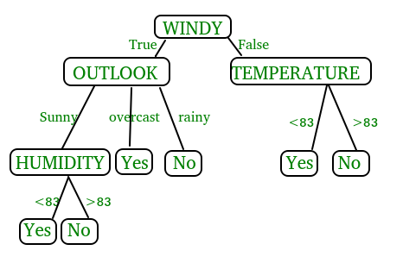
While implementing the decision tree we will go through the following two phases:
  - Building Phase
    - Preprocess the dataset.
    - Split the dataset from train and test using Python sklearn package.
    - Train the classifier.
  - Operational Phase
    - Make predictions.
    - Calculate the accuracy.

Data Import :
- To import and manipulate the data we are using the pandas package provided in python.
- Here, we are using a URL which is directly fetching the dataset from the UCI site no need to download the dataset. When you try to run this code on your system make sure the system should have an active Internet connection.
- As the dataset is separated by “,” so we have to pass the sep parameter’s value as “,”.
- Another thing is notice is that the dataset doesn’t contain the header so we will pass the Header parameter’s value as none. If we will not pass the header parameter then it will consider the first line of the dataset as the header.

Data Slicing :
- Before training the model we have to split the dataset into the training and testing dataset.
- To split the dataset for training and testing we are using the sklearn module train_test_split
- First of all we have to separate the target variable from the attributes in the dataset.
X = balance_data.values[:, 1:5]
Y = balance_data.values[:,0]
- Above are the lines from the code which sepearte the dataset. The variable X contains the attributes while the variable Y contains the target variable of the dataset.
- Next step is to split the dataset for training and testing purpose.
X_train, X_test, y_train, y_test = train_test_split(
X, Y, test_size = 0.3, random_state = 100)
- Above line split the dataset for training and testing. As we are spliting the dataset in a ratio of 70:30 between training and testing so we are pass test_size parameter’s value as 0.3.
- random_state variable is a pseudo-random number generator state used for random sampling.

Program:

# Decision Tree Classifier

# IMPORT LIBRARIES
import numpy as np
import matplotlib.pyplot as plt
import pandas as pd

# IMPORTING DATASET
dataset = pd.read_csv("2_Classification/Social_Network_Ads.csv")
X = dataset.iloc[:, [2, 3]].values
y = dataset.iloc[:, 4].values

# Splitting Data into Training & Testing
from sklearn.model_selection import train_test_split
X_train, X_test, y_train, y_test = train_test_split(X, y, test_size = 0.25, random_state = 0)

# Feature Scaling
from sklearn.preprocessing import StandardScaler
sc_X = StandardScaler()
X_train = sc_X.fit_transform(X_train)
X_test = sc_X.transform(X_test)
# DT is not based on Euclideam Distances
# We need some interpretations
# We need actual values and regions

# Fitting Logistic Regression to the Training set
from sklearn.tree import DecisionTreeClassifier
classifier = DecisionTreeClassifier(criterion='entropy', random_state=0)
classifier.fit(X_train, y_train)

# Predicting the Test set results
y_pred = classifier.predict(X_test)

for i in range(len(y_pred)):
print(y_test[i], y_pred[i])

# Making the Confusion Matrix
from sklearn.metrics import confusion_matrix
cm = confusion_matrix(y_test, y_pred)

# Visualising the Training set results
from matplotlib.colors import ListedColormap
X_set, y_set = X_train, y_train
X1, X2 = np.meshgrid(np.arange(start = X_set[:, 0].min() - 1, stop = X_set[:, 0].max() + 1, step = 0.01),
np.arange(start = X_set[:, 1].min() - 1, stop = X_set[:, 1].max() + 1, step = 0.01))
plt.contourf(X1, X2, classifier.predict(np.array([X1.ravel(), X2.ravel()]).T).reshape(X1.shape),
alpha = 0.75, cmap = ListedColormap(('red', 'green')))
plt.xlim(X1.min(), X1.max())
plt.ylim(X2.min(), X2.max())
for i, j in enumerate(np.unique(y_set)):
plt.scatter(X_set[y_set == j, 0], X_set[y_set == j, 1],
c = ListedColormap(('red', 'green'))(i), label = j)
plt.title('Decision Tree (Train set)')
plt.xlabel('Age')
plt.ylabel('Estimated Salary')
plt.legend()
plt.show()

# Visualising the Test set results
from matplotlib.colors import ListedColormap
X_set, y_set = X_test, y_test
X1, X2 = np.meshgrid(np.arange(start = X_set[:, 0].min() - 1, stop = X_set[:, 0].max() + 1, step = 0.01),
np.arange(start = X_set[:, 1].min() - 1, stop = X_set[:, 1].max() + 1, step = 0.01))
plt.contourf(X1, X2, classifier.predict(np.array([X1.ravel(), X2.ravel()]).T).reshape(X1.shape),
alpha = 0.75, cmap = ListedColormap(('red', 'green')))
plt.xlim(X1.min(), X1.max())
plt.ylim(X2.min(), X2.max())
for i, j in enumerate(np.unique(y_set)):
plt.scatter(X_set[y_set == j, 0], X_set[y_set == j, 1],
c = ListedColormap(('red', 'green'))(i), label = j)
plt.title('Decision Tree (Test set)')
plt.xlabel('Age')
plt.ylabel('Estimated Salary')
plt.legend()
plt.show()

G.H.RAISONI COLLEGE OF ENGINEERING, WAGHOLI, PUNE
DEPARTMENT OF COMPUTER ENGINEERING

Assignment no.13
Aim: Classification: Using SVM Predict if a customer with certain age and Salary will purchase a product or not

Learning Objective: To study classification algorithms

Theory:

What is Support Vector Machine?
“Support Vector Machine” (SVM) is a supervised machine learning algorithm which can be used for both classification or regression challenges. However, it is mostly used in classification problems. In this algorithm, we plot each data item as a point in n-dimensional space (where n is number of features you have) with the value of each feature being the value of a particular coordinate. Then, we perform classification by finding the hyper-plane that differentiate the two classes very well (look at the below snapshot).
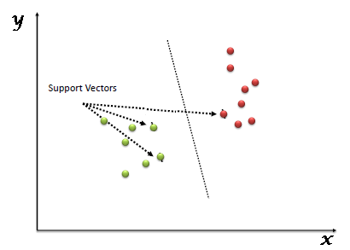
Support Vectors are simply the co-ordinates of individual observation. Support Vector Machine is a frontier which best segregates the two classes (hyper-plane/ line).
You can look at definition of support vectors and a few examples of its working here.

How does it work?
Above, we got accustomed to the process of segregating the two classes with a hyper-plane. Now the burning question is “How can we identify the right hyper-plane?”. Don’t worry, it’s not as hard as you think!
Let’s understand:
- Identify the right hyper-plane (Scenario-1): Here, we have three hyper-planes (A, B and C). Now, identify the right hyper-plane to classify star and circle.
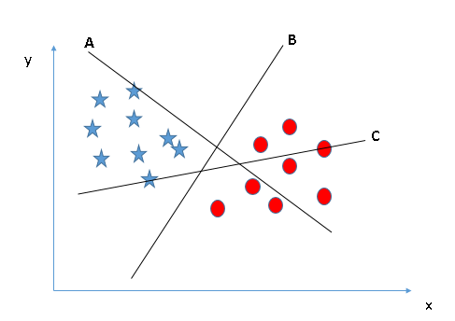
You need to remember a thumb rule to identify the right hyper-plane: “Select the hyper-plane which segregates the two classes better”. In this scenario, hyper-plane “B” has excellently performed this job.
- Identify the right hyper-plane (Scenario-2): Here, we have three hyper-planes (A, B and C) and all are segregating the classes well. Now, How can we identify the right hyper-plane?
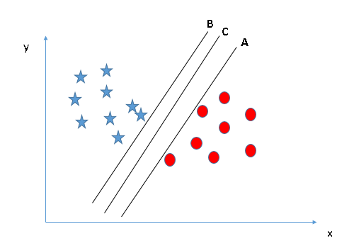
Here, maximizing the distances between nearest data point (either class) and hyper-plane will help us to decide the right hyper-plane. This distance is called as Margin. Let’s look at the below snapshot: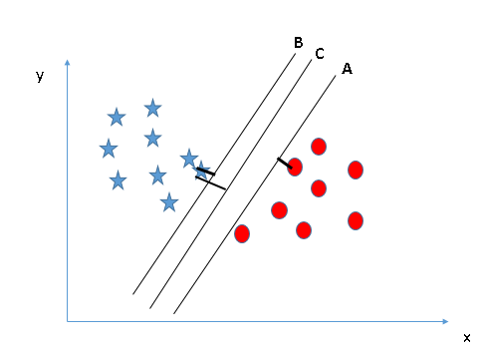
Above, you can see that the margin for hyper-plane C is high as compared to both A and B. Hence, we name the right hyper-plane as C. Another lightning reason for selecting the hyper-plane with higher margin is robustness. If we select a hyper-plane having low margin then there is high chance of miss-classification.
- Identify the right hyper-plane (Scenario-3):Hint: Use the rules as discussed in previous section to identify the right hyper-plane
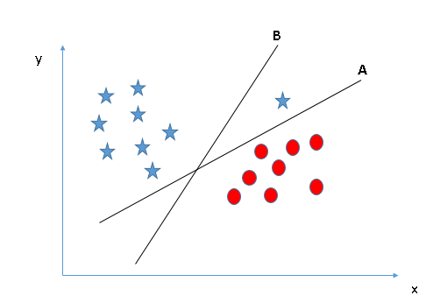
Some of you may have selected the hyper-plane B as it has higher margin compared to A. But, here is the catch, SVM selects the hyper-plane which classifies the classes accurately prior to maximizing margin. Here, hyper-plane B has a classification error and A has classified all correctly. Therefore, the right hyper-plane is A.
- Can we classify two classes (Scenario-4)?: Below, I am unable to segregate the two classes using a straight line, as one of star lies in the territory of other(circle) class as an outlier.
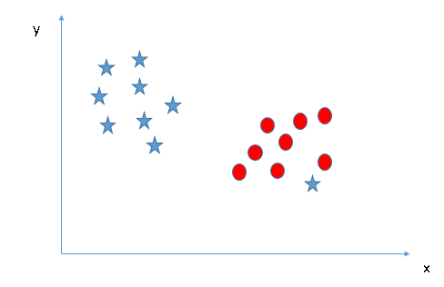
As I have already mentioned, one star at other end is like an outlier for star class. SVM has a feature to ignore outliers and find the hyper-plane that has maximum margin. Hence, we can say, SVM is robust to outliers.
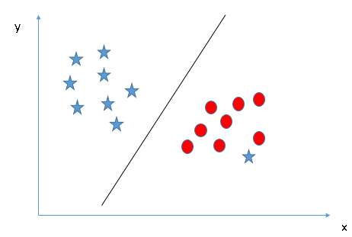
- Find the hyper-plane to segregate to classes (Scenario-5): In the scenario below, we can’t have linear hyper-plane between the two classes, so how does SVM classify these two classes? Till now, we have only looked at the linear hyper-plane.
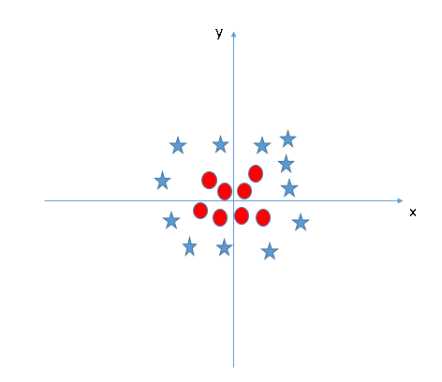
SVM can solve this problem. Easily! It solves this problem by introducing additional feature. Here, we will add a new feature z=x^2+y^2. Now, let’s plot the data points on axis x and z:
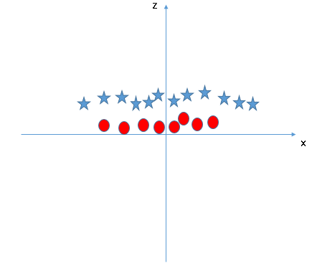
In above plot, points to consider are:
  - All values for z would be positive always because z is the squared sum of both x and y
  - In the original plot, red circles appear close to the origin of x and y axes, leading to lower value of z and star relatively away from the origin result to higher value of z.
In SVM, it is easy to have a linear hyper-plane between these two classes. But, another burning question which arises is, should we need to add this feature manually to have a hyper-plane. No, SVM has a technique called the kernel trick. These are functions which takes low dimensional input space and transform it to a higher dimensional space i.e. it converts not separable problem to separable problem, these functions are called kernels. It is mostly useful in non-linear separation problem. Simply put, it does some extremely complex data transformations, then find out the process to separate the data based on the labels or outputs you’ve defined.
When we look at the hyper-plane in original input space it looks like a circle:
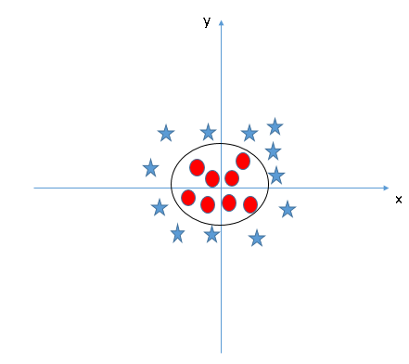

How to implement SVM in Python?
In Python, scikit-learn is a widely used library for implementing machine learning algorithms, SVM is also available in scikit-learn library and follow the same structure (Import library, object creation, fitting model and prediction).
Program:

# SVM
# IMPORT LIBRARIES
import numpy as np
import matplotlib.pyplot as plt
import pandas as pd

# IMPORTING DATASET
dataset = pd.read_csv("2_Classification/Social_Network_Ads.csv")
X = dataset.iloc[:, [2, 3]].values
y = dataset.iloc[:, 4].values

# Splitting Data into Training & Testing
from sklearn.cross_validation import train_test_split
X_train, X_test, y_train, y_test = train_test_split(X, y, test_size = 0.25, random_state = 0)

# Feature Scaling
from sklearn.preprocessing import StandardScaler
sc_X = StandardScaler()
X_train = sc_X.fit_transform(X_train)
X_test = sc_X.transform(X_test)

# Fitting SVM to the Training set
from sklearn.svm import SVC
classifier = SVC(kernel='rbf', random_state=0)
# C = Penalty Parameter
# Kernel = RBF, LINEAR, POLY, SIGMOID
# Degree = If you choose POLY
classifier.fit(X_train, y_train)

# Predicting the Test set results
y_pred = classifier.predict(X_test)

# for i in range(len(y_pred)):
# print(X_test[i, :], y_pred[i])

# Making the Confusion Matrix
from sklearn.metrics import confusion_matrix
cm = confusion_matrix(y_test, y_pred)

# Visualising the Training set results
from matplotlib.colors import ListedColormap
X_set, y_set = X_train, y_train
X1, X2 = np.meshgrid(np.arange(start = X_set[:, 0].min() - 1, stop = X_set[:, 0].max() + 1, step = 0.01),
np.arange(start = X_set[:, 1].min() - 1, stop = X_set[:, 1].max() + 1, step = 0.01))
plt.contourf(X1, X2, classifier.predict(np.array([X1.ravel(), X2.ravel()]).T).reshape(X1.shape),
alpha = 0.75, cmap = ListedColormap(('red', 'green')))
plt.xlim(X1.min(), X1.max())
plt.ylim(X2.min(), X2.max())
for i, j in enumerate(np.unique(y_set)):
plt.scatter(X_set[y_set == j, 0], X_set[y_set == j, 1],
c = ListedColormap(('red', 'green'))(i), label = j)
plt.title('SVM (Test set)')
plt.xlabel('Age')
plt.ylabel('Estimated Salary')
plt.legend()
plt.show()

# Visualising the Test set results
from matplotlib.colors import ListedColormap
X_set, y_set = X_test, y_test
X1, X2 = np.meshgrid(np.arange(start = X_set[:, 0].min() - 1, stop = X_set[:, 0].max() + 1, step = 0.01),
np.arange(start = X_set[:, 1].min() - 1, stop = X_set[:, 1].max() + 1, step = 0.01))
plt.contourf(X1, X2, classifier.predict(np.array([X1.ravel(), X2.ravel()]).T).reshape(X1.shape),
alpha = 0.75, cmap = ListedColormap(('red', 'green')))
plt.xlim(X1.min(), X1.max())
plt.ylim(X2.min(), X2.max())
for i, j in enumerate(np.unique(y_set)):
plt.scatter(X_set[y_set == j, 0], X_set[y_set == j, 1],
c = ListedColormap(('red', 'green'))(i), label = j)
plt.title('SVM (Test set)')
plt.xlabel('Age')
plt.ylabel('Estimated Salary')
plt.legend()
plt.show()

G.H.RAISONI COLLEGE OF ENGINEERING, WAGHOLI, PUNE
DEPARTMENT OF COMPUTER ENGINEERING
Assignment no.14
Aim: Classification: Using RFC Predicting if a customer with certain age and Salary will purchase a product or not.

Learning Objective: To study classification algorithms
Theory:
Random forest is a type of supervised machine learning algorithm based on ensemble learning. Ensemble learning is a type of learning where you join different types of algorithms or same algorithm multiple times to form a more powerful prediction model. The random forest algorithm combines multiple algorithm of the same type i.e. multiple decision trees, resulting in a forest of trees, hence the name "Random Forest". The random forest algorithm can be used for both regression and classification tasks.

How the Random Forest Algorithm Works
The following are the basic steps involved in performing the random forest algorithm:
- Pick N random records from the dataset.
- Build a decision tree based on these N records.
- Choose the number of trees you want in your algorithm and repeat steps 1 and 2.
- In case of a regression problem, for a new record, each tree in the forest predicts a value for Y (output). The final value can be calculated by taking the average of all the values predicted by all the trees in forest. Or, in case of a classification problem, each tree in the forest predicts the category to which the new record belongs. Finally, the new record is assigned to the category that wins the majority vote.

How does the algorithm work?
It works in four steps:
- Select random samples from a given dataset.
- Construct a decision tree for each sample and get a prediction result from each decision tree.
- Perform a vote for each predicted result.
- Select the prediction result with the most votes as the final prediction.
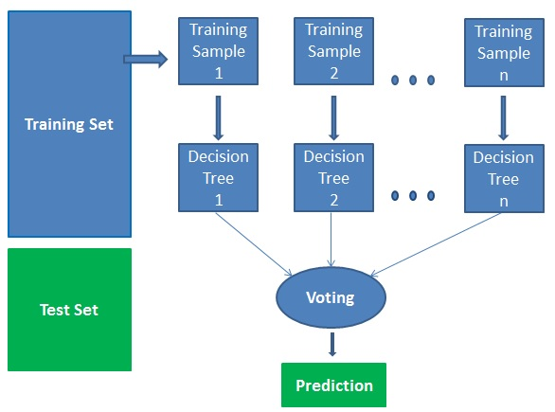

Advantages of using Random Forest
As with any algorithm, there are advantages and disadvantages to using it. In the next two sections we'll take a look at the pros and cons of using random forest for classification and regression.
- The random forest algorithm is not biased, since, there are multiple trees and each tree is trained on a subset of data. Basically, the random forest algorithm relies on the power of "the crowd"; therefore the overall biasedness of the algorithm is reduced.
- This algorithm is very stable. Even if a new data point is introduced in the dataset the overall algorithm is not affected much since new data may impact one tree, but it is very hard for it to impact all the trees.
- The random forest algorithm works well when you have both categorical and numerical features.
- The random forest algorithm also works well when data has missing values or it has not been scaled well (although we have performed feature scaling in this article just for the purpose of demonstration).

Disadvantages of using Random Forest
- A major disadvantage of random forests lies in their complexity. They required much more computational resources, owing to the large number of decision trees joined together.
- Due to their complexity, they require much more time to train than other comparable algorithms.

Program:

# IMPORT LIBRARIES
import numpy as np
import matplotlib.pyplot as plt
import pandas as pd

# IMPORTING DATASET
dataset = pd.read_csv("2_Classification/Social_Network_Ads.csv")
X = dataset.iloc[:, [2, 3]].values
y = dataset.iloc[:, 4].values
dataset.plot()
# Splitting Data into Training & Testing
from sklearn.model_selection import train_test_split
X_train, X_test, y_train, y_test = train_test_split(X, y, test_size = 0.25, random_state = 0)

# Feature Scaling
from sklearn.preprocessing import StandardScaler
sc_X = StandardScaler()
X_train = sc_X.fit_transform(X_train)
X_test = sc_X.transform(X_test)

# Fitting Random Forest class to the Training set
from sklearn.ensemble import RandomForestClassifier
classifier = RandomForestClassifier(n_estimators=10, criterion='entropy', random_state=0)
classifier.fit(X_train, y_train)

# Predicting the Test set results
y_pred = classifier.predict(X_test)

# for i in range(len(y_pred)):
# print(X_test[i, :], y_pred[i])

# Making the Confusion Matrix
from sklearn.metrics import confusion_matrix
cm = confusion_matrix(y_test, y_pred)

# Visualising the Training set results
from matplotlib.colors import ListedColormap
X_set, y_set = X_train, y_train
X1, X2 = np.meshgrid(np.arange(start = X_set[:, 0].min() - 1, stop = X_set[:, 0].max() + 1, step = 0.01),
np.arange(start = X_set[:, 1].min() - 1, stop = X_set[:, 1].max() + 1, step = 0.01))
plt.contourf(X1, X2, classifier.predict(np.array([X1.ravel(), X2.ravel()]).T).reshape(X1.shape),
alpha = 0.75, cmap = ListedColormap(('red', 'green')))
plt.xlim(X1.min(), X1.max())
plt.ylim(X2.min(), X2.max())
for i, j in enumerate(np.unique(y_set)):
plt.scatter(X_set[y_set == j, 0], X_set[y_set == j, 1],
c = ListedColormap(('red', 'green'))(i), label = j)
plt.title('Random forest classification (Train set)')
plt.xlabel('Age')
plt.ylabel('Estimated Salary')
plt.legend()
plt.show()

# Visualising the Test set results
from matplotlib.colors import ListedColormap
X_set, y_set = X_test, y_test
X1, X2 = np.meshgrid(np.arange(start = X_set[:, 0].min() - 1, stop = X_set[:, 0].max() + 1, step = 0.01),
np.arange(start = X_set[:, 1].min() - 1, stop = X_set[:, 1].max() + 1, step = 0.01))
plt.contourf(X1, X2, classifier.predict(np.array([X1.ravel(), X2.ravel()]).T).reshape(X1.shape),
alpha = 0.75, cmap = ListedColormap(('red', 'green')))
plt.xlim(X1.min(), X1.max())
plt.ylim(X2.min(), X2.max())
for i, j in enumerate(np.unique(y_set)):
plt.scatter(X_set[y_set == j, 0], X_set[y_set == j, 1],
c = ListedColormap(('red', 'green'))(i), label = j)
plt.title('Random forest classification (Test set)')
plt.xlabel('Age')
plt.ylabel('Estimated Salary')
plt.legend()
plt.show()

G.H.RAISONI COLLEGE OF ENGINEERING, WAGHOLI, PUNE
DEPARTMENT OF COMPUTER ENGINEERING

Assignment no.15
Aim: Clustering: Using K-Means clustering, determine Customers of a Mall according to Categories so as to launch a scheme for business growth a product or not for imbalanced data and determining Fitting issues and Sampling methods and Optimizing techniques.

Learning Objective: To study clustering algorithms

Theory:

K-Means clustering is an unsupervised learning algorithm that, as the name hints, finds a fixed number (k) of clusters in a set of data. A cluster is a group of data points that are grouped together due to similarities in their features. When using a K-Means algorithm, a cluster is defined by a centroid, which is a point (either imaginary or real) at the center of a cluster. Every point in a data set is part of the cluster whose centroid is most closely located. To put it simply, K-Means finds k number of centroids, and then assigns all data points to the closest cluster, with the aim of keeping the centroids small.

The Algorithm
K-Means starts by randomly defining k centroids. From there, it works in iterative (repetitive) steps to perform two tasks:
- Assign each data point to the closest corresponding centroid, using the standard Euclidean distance. In layman’s terms: the straight-line distance between the data point and the centroid.
- For each centroid, calculate the mean of the values of all the points belonging to it. The mean value becomes the new value of the centroid.
Once step 2 is complete, all of the centroids have new values that correspond to the means of all of their corresponding points. These new points are put through steps one and two producing yet another set of centroid values. This process is repeated over and over until there is no change in the centroid values, meaning that they have been accurately grouped. Or, the process can be stopped when a previously determined maximum number of steps has been met.

Applying the K-Means Algorithm
Iteration 1: First, we create two randomly generated centroids and assign each data point to the cluster of the closest centroid. In this case, because we are using two centroids, our k value is 2.

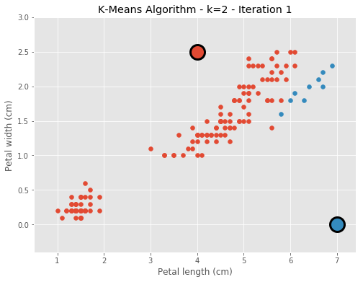

Iteration 2: As you can see above, the centroids are not evenly distributed. In the second iteration of the algorithm, the average values of each of the two clusters are found and become the new centroid values.
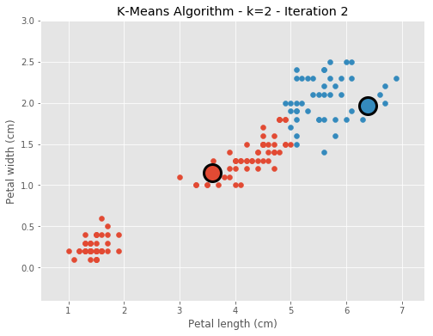
Iterations 3-5: We repeat the process until there is no further change in the value of the centroids.
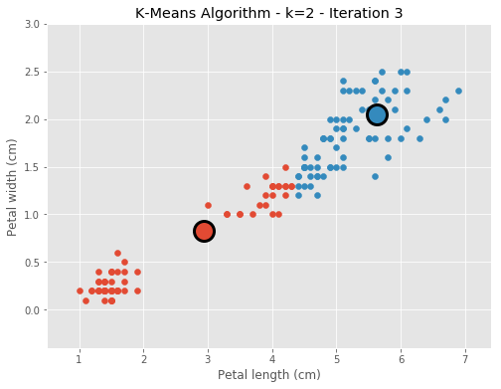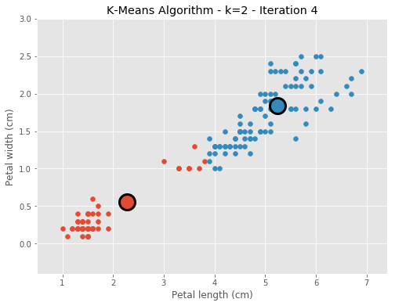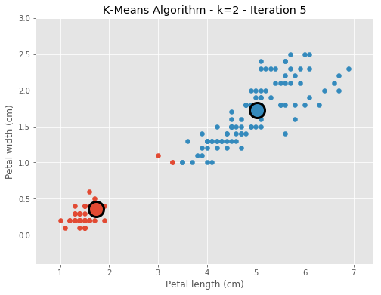

Finally, after iteration 5, there is no further change in the clusters.

Choosing K
The algorithm explained above finds clusters for the number k that we chose. So, how do we decide on that number?
To find the best k we need to measure the quality of the clusters. The most traditional and straightforward method is to start with a random k, create centroids, and run the algorithm as we explained above. A sum is given based on the distances between each point and its closest centroid. As an increase in clusters correlates with smaller groupings and distances, this sum will always decrease when k increases; as an extreme example, if we choose a k value that is equal to the number of data points that we have, the sum will be zero.
The goal with this process is to find the point at which increasing k will cause a very small decrease in the error sum, while decreasing k will sharply increase the error sum. This sweet spot is called the “elbow point.” In the image below, it is clear that the “elbow” point is at k-3.
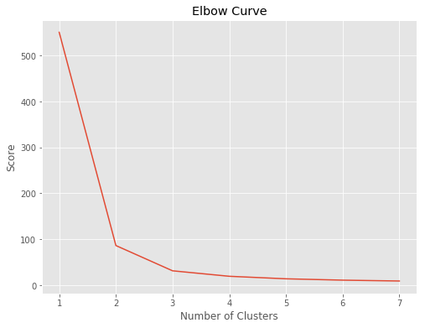
Now, let’s take a look at the visual differences between using two, three, four, or five clusters.
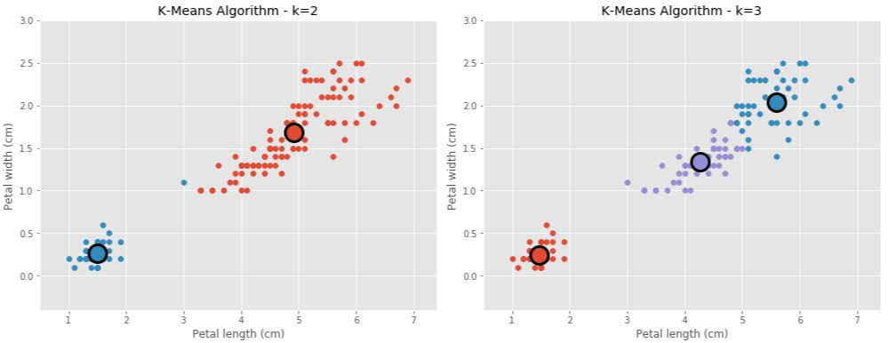
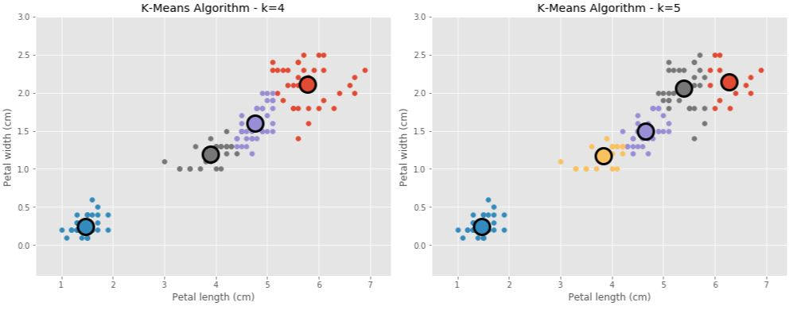

The different graphs also show that three is the most appropriate k value, which makes sense when taking into account that the data contains three types of iris flowers.
The K-Means algorithm is a great example of a simple, yet powerful algorithm. For example, it can be used to cluster phishing attacks with the objective of discovering common patters and even discovering new phishing kits. It can also be used to understand fraudulent patterns in financial transactions.
Advantages of K-Means:
- Widely used method for cluster analysis
- Easy to understand
- Trains quickly
Disadvantages of K-Means:
- Euclidean distance is not ideal in many applications
- Performance is (generally) not competitive with the best clustering methods
- Small variations in the data can result in a completely different clusters (high variance)
- Clusters are assumed to have a spherical shape and be evenly sized
Program:

# K MEANS CLUSTERING

# Importing the Libraries

import numpy as np
import matplotlib.pyplot as plt
import pandas as pd

# Import Mall Dataset
dataset = pd.read_csv('3_Clustering/Mall_Customers.csv')
# Clients that subscribe to Membership card
# Maintains the Purchase history
# Score is Dependent on INCOME,
# No. times in week the show up in Mall, total expense in same mall
# YOU ARE!!
# TO Segment Clients into Different Groups based on Income & Score
# CLUSTERING PROBLEM
X = dataset.iloc[:, [3, 4]].values
# We have no Idea to look for
# We don't know the Optimal no. of Clusters

# USE ELBOW METHOD
from sklearn.cluster import KMeans
wcss = []
for i in range(1, 11):
# Fit values into KM
kmeans = KMeans(n_clusters=i, init='k-means++', max_iter=300, n_init=10, random_state=0)
kmeans.fit(X)
wcss.append(kmeans.inertia_)
plt.plot(range(1, 11), wcss)
plt.title("ELBOW METHOD")
plt.xlabel("No. of Clus")
plt.ylabel("WCSS")
plt.plot()

# Applying K-means to Mall
kmeans = KMeans(n_clusters=5, init='k-means++', max_iter=300, n_init=10, random_state=0)
y_kmeans = kmeans.fit_predict(X)

# Visualising the Clusters
plt.scatter(X[y_kmeans==0, 0], X[y_kmeans==0, 1], s= 100, c = 'red', label='Cluster1')
plt.scatter(X[y_kmeans==1, 0], X[y_kmeans==0, 1], s= 100, c = 'blue', label='Cluster2')
plt.scatter(X[y_kmeans==2, 0], X[y_kmeans==0, 1], s= 100, c = 'yellow', label='Cluster3')
plt.scatter(X[y_kmeans==3, 0], X[y_kmeans==0, 1], s= 100, c = 'green', label='Cluster4')
plt.scatter(X[y_kmeans==4, 0], X[y_kmeans==0, 1], s= 100, c = 'cyan', label='Cluster5')
plt.scatter(kmeans.cluster_centers_[:, 0], kmeans.cluster_centers_[:, 1], s=300, c = 'red', label='Cluster1')
plt.title('Clusters of customers')
plt.xlabel('Annual Income (k$)')
plt.ylabel('Spending Score (1-100)')
plt.legend()
plt.show()

